
K&M Tire

Training and Development
12/5/2024

Table of Contents
1. K&M Tire 1
2. Training & Development Department Mission 4
2.1 Training & Development 4
2.2 Training Content Planning & Best Practices 5
2.3 Training Content Creation, Delivery, and Debrief 6
2.4 ELT Training Input Discussion Framework 10
2.5 Training Content Lifecycle 10
2.6 Training Calendar and Map 11
2.7 Weekly Update Meeting Expectations 12
2.8 Monthly Communication Expectations 14
2.9 Training Overview 15
2.10 Leadership Development Training Program 16
2.11 Workplace Excellence Training Program 17
2.12 Preparing, Creating and Delivering a Business Excellence Training Module 18
2.13 Operations Excellence Training Program 21
2.14 Operations Excellence Training SOP 22
2.15 Sales Excellence Training Program 25
2.16 Sales Excellence Training SOP 26
2.17 Next Steps Leadership Program 29
2.18 Driving Excellence Training Program 30
2.19 Business Excellence Training 31
2.20 Department-Specific Training 32
2.21 New Team Member Orientation 32
2.22 New Team Member Orientation SOP 33
2.23 Virtual Training SOP’s 35
2.24 Digital Content Hosting and Management 37
2.25 Training Satisfaction Surveys 38
2.26 Continuous improvement Initiatives 39
2.27 SOP For Working with A Freelance Professional 41
2.28 CG Shorts 43
3. Quote of the Week 45
4. Word of the Month 46
5. Degreed 48
5.1 Degreed Instructions on Set-Up SOP – For Talent Development (Admin) 48
5.2 Member User (Employee) 66
5.3 Designing a Development Plan in Degreed 70
6. Predictive Index 74
6.1 Predictive Index Behavioral Assessment SOP 74
6.2 Predictive Index Behavioral Assessment Debrief 78
7. Training Programs 80
7.1 IDP Process 80
7.2 Leadership Fundamental Training 87
7.3 93
7.4 Mid-Level Leadership Development Program 93
8. Frequently Asked Questions 102
Appendix A: Miscellaneous 103
Appendix H: Revision History Tracking 104

List of Figures
No table of figures entries found.

List of Tables
Table 1 - Support Points of Contact 115
Table 2 - Acronyms 119
Table 3 - Glossary 121
Table 4 - Referenced Documents 122
Table 5 - Approvals 124
Table 6 - Revision History Tracking 127

K&M Tire
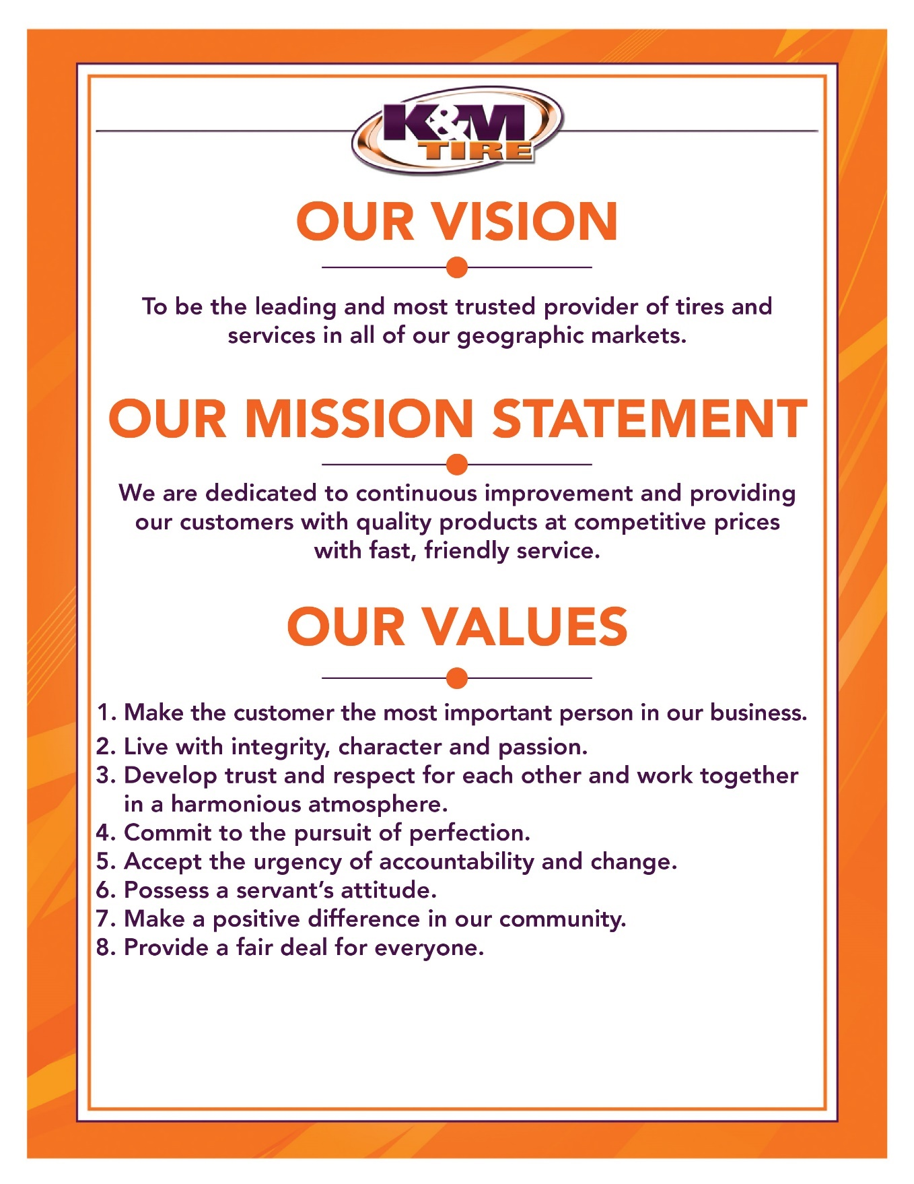

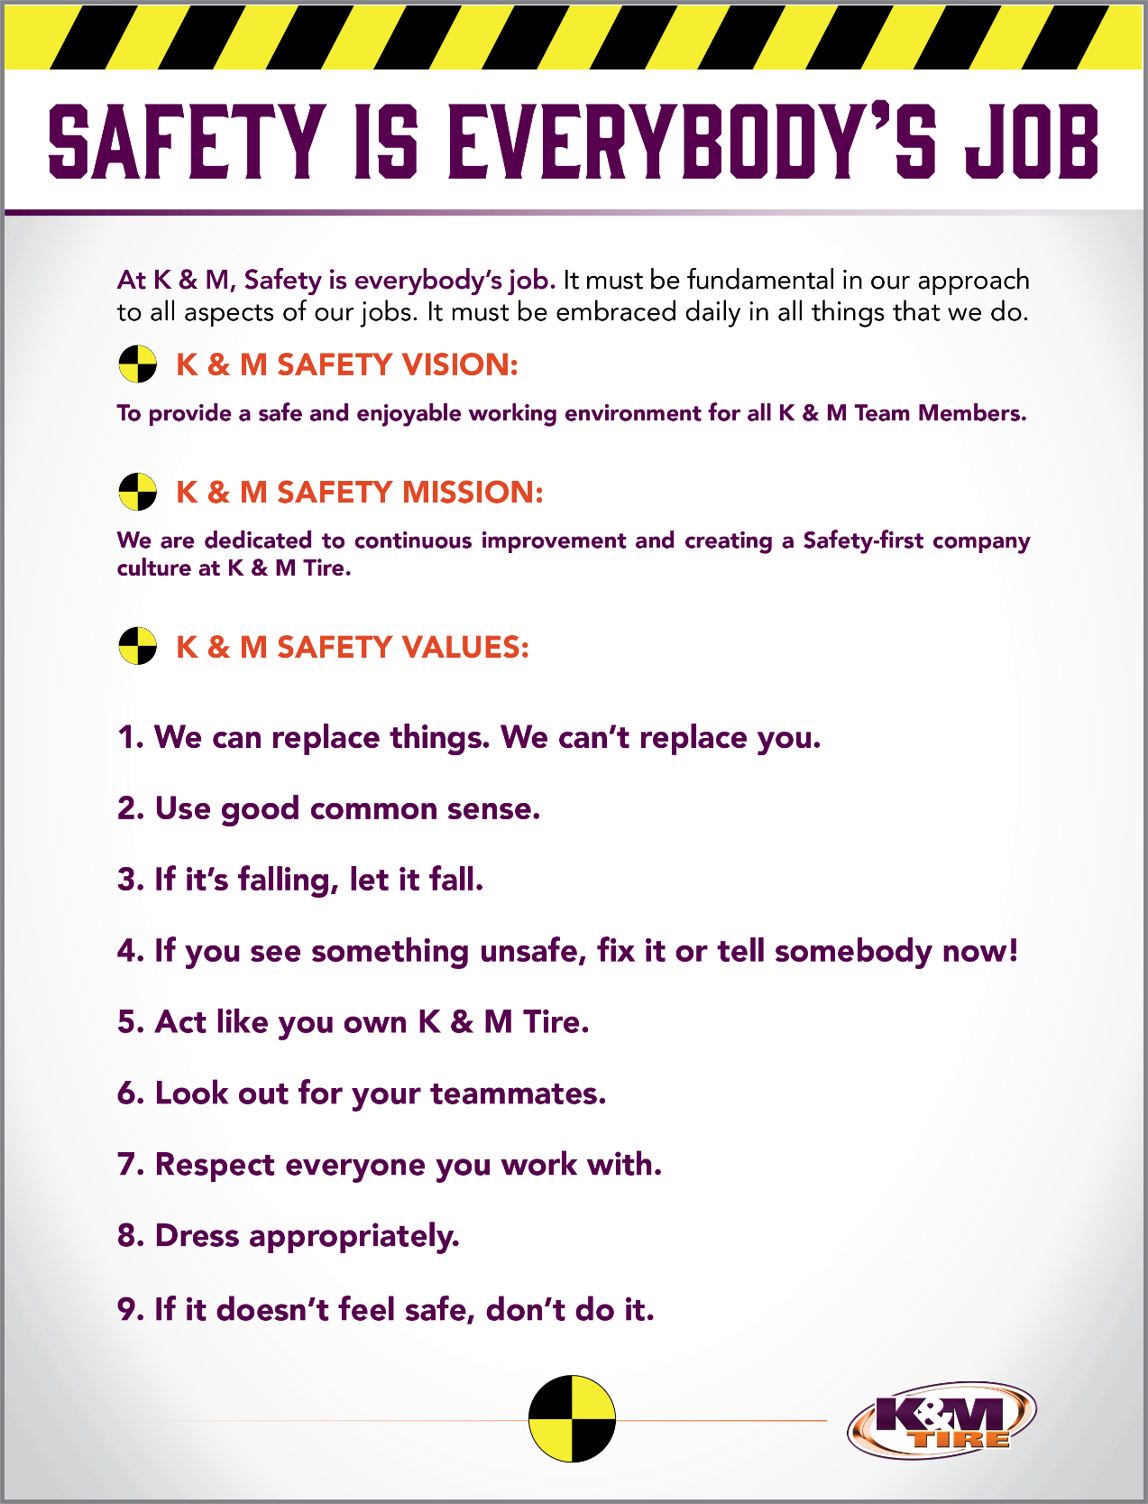

K&M Tire US Footprint
Click on the below link to see the footprint map
http://kmtire.com/km-cgi/distmap

Training & Development Department Mission

Training & Development
- TO BE A TRUSTED PARTNER WHO COLLABORATES WITH THE BUSINESS AND CONNECTS EMPLOYEES TO SOLUTIONS THAT DRIVE ENGAGEMENT.

  - Trusted Partner means that we prioritize and protect K&M Tire, while serving our team of professionals.

  - Collaborates means that we are genuinely dedicated to listening to those we serve, especially our key stakeholders and training audiences.

  - Connects means that we facilitate solutions and hold ourselves accountable until the job is done. Not when it’s most convenient for us.

  - Engagement means that our team is clear on what’s most important right now and aligned around working toward achieving our top priorities.

- KEY PRIORITIES:

- Do my part to ensure we have the right people and resources in place to grow our training & development.
- Remain aligned with our Development and HR teams at all times. This will require me to be intentional about meeting and talking with the Manager of Talent Development and Director of HR.
- I must grow and maintain excellent working relationships with all ELT, managers, and supervisors to continue to grow support for our training and development throughout the entire organization.
- Be intentional about consistently asking our ELT for feedback, genuinely listening, and remaining agile/flexible.
- Continually increase my capacity to continually bring people to the next level.

- CONTINUOUS IMPROVEMENT:

- Continue asking a lot of questions of the VP of HR and others on ELT to gain knowledge, understanding and alignment. Proactively review programs to ensure they are accomplishing intended result.

- TRAINING GOALS:

- Ensure every program now and in the future has a documented structure and plan so it is repeatable.

Training Content Planning & Best Practices
When creating training content for both live and digital training, extra thought should be given to the planning process to ensure that the delivered content is aligned with expectations and goals and accomplishes the stated training objective.
- Below is a basic outline that can be used during the planning process to ensure that the training delivered is effective and on-target:
  - Training Program
- Training Audience:
- Training Title:
- Training Objective:
- Intended Key Takeaways:
- Scheduled Shoot Date (if video):
- Scheduled Go-Live Date:

- Training Reminders:
- Video-based training should be timeless and should not reference current events or situations.
- Relatively short opening with clearly-stated training objective
- State early what the go-forward commitment will be and then repeat near the end.
- Remember to smile, warm opening, slow down when necessary, and use purposeful gestures
- Emphasize key points with meaningful quotes and bold where you want graphics inserted into training scripts.
- Remember the rule of 3’s, use acronyms periodically to help with memorization and comprehension, and include K&M-specific examples where possible.
- Summarize what we’ve covered thus far and repeat primary lessons multiple times to help with audience comprehension.
- When including contributions from guest speakers, ask them to record audio and email the audio file as opposed to simply including a text quote on the screen.
- Include a narrative arc to tell a story, finish with a commitment to action, and clear next steps.
- Keep the audience training workbook in mind when writing scripts and reference the training satisfaction survey where applicable.
- External training content can be used to reinforce key points and should be customized where possible to the way that K&M Tire does business as much as possible.
- When conducting video-based training, the Director of Training should coordinate and maintain consistent communication with the Digital Communication Specialist.

Training Content Creation, Delivery, and Debrief
- Step one: Pre-Planning Discussion - At this stage, the Director of Training (DT) should conduct an initial high-level discussion with the VP of HR (VPHR) to ensure clarity and alignment from the very start.

  - This step is critical to ensure that the DT does not become misaligned with the VPHR as a result of working with the Manager of Talent Development (MTD) or other members of the ELT.

  - The VPHR may proactively send initial thoughts via email to the DT to get the discussion moving in the right direction.

  - The DT should come prepared with some initial thoughts and pro-planned questions to get the conversation started.

  - Additionally, the DT may utilize a half page pre-planning discussion template, which answers the crucial question: What is the challenge we are seeking to address with this training? This template is shown below and is also linked here.

  - This pre-planning discussion is to remain strictly confidential between the VPHR and the DT to ensure full transparency and to ensure that confidential information is not shared with others as a result of the pre-planning discussion.

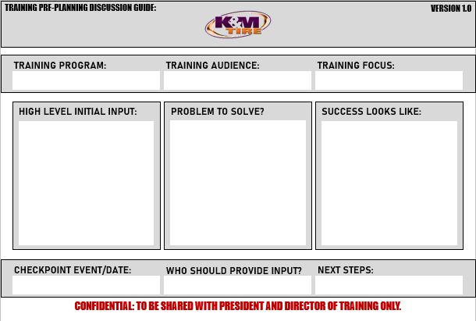

- Step two: Initial Discussion with VPHR – At this stage, the DT should deliver and discuss with the VPHR the training topic, which has been pre-selected in the annual training mapping and planning process along with the tool with which to most effectively train the audience on the primary training topic.

  - Once step one is properly completed, the DT should draft and send an email to the VPHR approximately 2 – 3 days in advance of the following weekly meeting with the primary training topic, the primary training tool, and a 1 -2 sentence brief description of each step or stage of the training tool.

  - The email should be relatively brief and should give the VPHR a high-level understanding of the training topic, the training tool and how the tool will be used to effectively train the audience on the primary training topic.
- An example of this could be the 5 C’s of effective communication or the DMAIC framework for process improvement, etc.

  - This discussion should be added to the following weekly meeting agenda and the DT should come prepared to discuss the training topic and training tool with the VPHR.

  - DT should come prepared to take notes based on the discussion with the VPHR with the intent to determine how best to incorporate the training tool into the training session and also how best to engage the audience to apply the training tool during the training and then challenge the audience to take action based on the training.

  - This is to be completed approximately six weeks in advance of the delivering training.

- Step Three: ELT Input – At this stage, the DT should actively seek input from others on the leadership team to determine how the training topic and selected training tool can be most effective, valuable, and useful for their teams.

- Once step two is completed, the Dt should seek out advice and input from others on the ELT. The DT should remain focused on the intended outcome, but flexible in the means with which to achieve the end outcome.

- Thought should be given to proper questions to ask ELT members in order to determine how best to utilize the training tool.

- In order to avoid groupthink, these discussions should be held individually and can be in person, via email, or by phone as ELT members maintain full calendars and travel schedules. The DT should aim to incorporate input from at least three other ELT members.

- The DT will find it helpful to gain insights from ELT members into how the identified training topic is already being utilized at K&M, where our team is already doing this well, where our team is not doing this well, and understand actual examples and success stories that reflect the training topic.

- This step is to be completed approximately 5-6 weeks in advance of delivering training.

- Step Four: Create Training Plan – At this stage, the DT is to create a comprehensive training plan including the training topic, training tool, ELT input, actual K&M examples, and proposed audience application exercises.

- The training plan should have a clear beginning, middle, and end. How will the training open, how will the training topic be trained, and how will the training close?
- Extra thought should be given to how primary training points will be emphasized, where outside training content will be included, and how the audience will be asked to engage with the training topic and tool.

- The primary purpose of our training at K&M is to train for action. In this way, additional thought should be given to how the audience will apply the training topic during the training and also what the audience will be asked to do after the training has been completed.

- For example, a 90-minute live training session could include 2-3 audience engagement activities or exercises, a commitment to take action towards the end of the training, and also a challenge that encourages the training audience to apply the training tool in their own work.

- This comprehensive training plan should be approximately 3-6 pages in length, but could be more or less depending on the training topic. This training plan should be delivered to the VPHR via email approximately 2-3 days in advance of the following weekly meeting and then added to the following meeting agenda for discussion.

- This is to be completed approximately 4-5 weeks in advance of delivering training.

- Step Five: Training Plan Discussion with VPHR – At this stage, the DT should come prepared to discuss the comprehensive training plan with the VPHR during the following scheduled weekly meeting.

- The DT should come prepared to take notes and determine where steps, tools, audience engagement activities, and examples can be improved on the way to creating the most effective training program possible.

- The DT should remain focused on the intended outcome, but flexible on the means with which to achieve the intended outcome(s).

- The DT should understand and recognize that this discussion may require some edits, additions, or subtractions from the initial training plan.

- This is to be completed approximately 4 weeks in advance of delivering training.

- Step Six: Create and deliver learning guide to VPHR – At this stage, the DT should create the document(s) that the training audience will utilize in order to engage with and apply the training tool during the training program. Many times, this may be an audience learning guide.

- The purpose of this step is to provide a clear understanding to the VPHR of how the audience will be asked to interact with and apply the training tool during and after the training.

- The learning guide may include the stated objective of the training, space for the audience to take notes, audience engagement exercises, self-assessments, individual journaling exercises, space to make a commitment to action, challenge(s) to the audience, case studies, and/or optional reading exercises to further reinforce the primary training objective.

- The learning guide will vary in length, but a 90-minute training session may include a learning guide in the range of 6-12 pages. This learning guide can be created in Microsoft Word or PowerPoint and should be presented as a professional document.

- The DT should deliver the learning guide to the VPHR via email at least 2-3 days in advance of the following weekly meeting and this should be added as an agenda item for the following weekly meeting.

- This should be completed approximately 2-3 weeks in advance of delivering training.

- Step Seven: Deliver Training – At this stage, the DT should deliver a professional training program with excellence, professionalism, clarity, and a focus on audience application and action.

- Live training sessions are to be held in the training room. Thought should be given to training class size, training class layout, where in the room group exercises may take place, and how the audience may view videos and/or the presentation (where applicable).

- All training delivered should support our annual training theme towards achieving our Training Mission: To build the leading and most trusted team.

- The primary training objective and key audience takeaways should be clear up front.

- The purpose of our training is to train for action. This will require actual training and facilitation can be used as a training tactic and to further engage the audience to interact with the training and the training tool.

- The DT should be prepared to ask for audience feedback. This can be done through an audience satisfaction survey. This can be delivered via email post-training. When using digital audience survey, it should be sent to the audience shortly after the training has commenced while the training information is still fresh in their minds. Digital training surveys can be created in Jotform.

- Step Eight: Debrief and Continuous Improvement – At this stage, the DT should actively seek feedback and advice on how to continually improve our training initiatives.

- DT will deliver via email a training recap to the VPHR, including what went well, where continuous improvement opportunities may exist, and audience training satisfaction survey results.
- This should be delivered to the VPHR via email at least one business day in advance of the following weekly meeting and then added as an agenda item for discussion.

- Prior to this meeting, the DT should give thought to what went well, what did not go as well as it should have, and where specific areas of opportunity exist.

- The DT should come prepared to discuss with the VPHR with a focus on improving the training. Constructive feedback is critical to K&M fulfilling our Mission of continuous improvement in all areas.

- This is to be completed within one week after delivering training and steps should be taken to incorporate select audience survey feedback and feedback from the VPHR into future training programs.

ELT Training Input Discussion Framework
- This document is intended to give structure and to lend intentionality to these ELT training input discussions. Actual conversation structure and flow may vary.
  - Why was this training topic selected?
  - What is the ultimate goal of this training?
  - How specifically does this training apply to your team and your department?
  - What are 1-2 of the pain points with your team as it pertains to this training topic?
  - What are 1-2 examples of this training topic from your team and your departments(s)?
  - What are some of the pain points with your team as it relates to this training topic?
  - What would a successful training session look like in your opinion?
  - How can I support you in driving sustainable post-training outcomes with your team?

- Towards the closing of this 15–25-minute conversation, create space and opportunity for the ELT member to reach out to you if and when they think of additional information, examples, or other input related to this specific training.

Training Content Lifecycle
- When creating new training content, it is imperative that the Director of Training & Development includes prior feedback from other ELT members and also communicates and calibrates the proposed training outline with the VPHR prior to actually creating the training. This requires time, intention, and being proactive with this process.

- Below is a framework that can be utilized to remain organized during the planning, communication, and creation processes for new training modules or classes. Note that not all training will require the filming or video setup processes. And because any organization periodically experiences employee turnover, the training audience should continually be confirmed to ensure that nobody in the intended training audience is unintentionally left out. The training audience should also periodically be calibrated with ELT members to ensure that we are including everyone in our training that should be included.

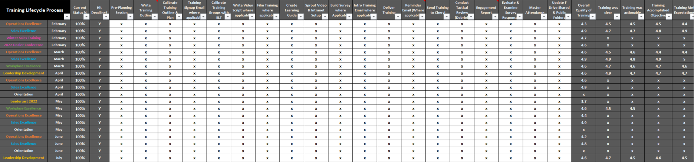

- This framework is available on the F drive as an editable Excel document: \\file-a.kmtire.local\File Server\Training & Development\Shared\MASTER TRAINING PLAN.xlsx

Training Calendar and Map
In the weeks leading up to the fourth calendar quarter of each year, the Director of Training should begin planning for the following years’ training calendar so that there is sufficient time to discuss following year training initiatives with the VPHR, create the calendar and proposal, present the proposal to the VPHR, and make adjustments as needed based on feedback from the VPHR and possibly also the ELT.
- An example of a successful annual training calendar can be found:
\\file-a.kmtire.local\File Server\Training & Development\Shared\MASTER TRAINING PLAN.xlsx and below are the items that should be included in the training calendar:
- Annual training theme
- How will we measure success in achieving our training theme?
- Training program name: i.e., Leadership Development
- Intended training audience: i.e., Delphos supervisors, managers, HR, ROM’s, RSM’s
- What will success look like?
- What are our program objectives?
- When will this training be conducted?
- What is the format of the training? i.e., Live with survey
- How will we measure success?
- What are the proposed training topics?

Below is an example of an effective training plan:
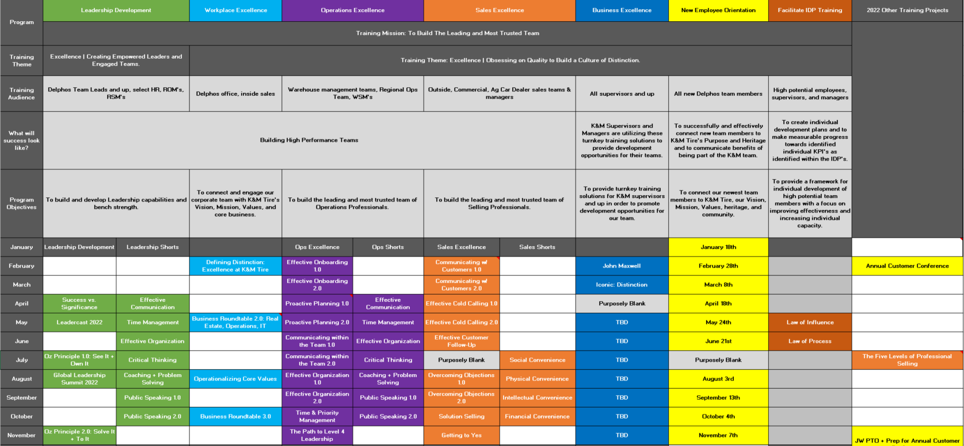

Weekly Update Meeting Expectations
The Director of Training will meet weekly with the VPHR to update them on training projects and initiatives and to discuss the details. These meetings should be clear, concise, and effective. Agenda items should be sent to the VPHR ahead of time so they can prepare for the meeting as their schedule allows.
- A meeting agenda and training status update report should be sent to the VPHR in advance of all weekly meetings. For summaries and overviews, these items can be sent before 10am ET prior to weekly meetings on the day of the meeting.
- For items requiring additional review, the VPHR may choose to look through more comprehensive meeting items as their schedule allows and may circle back at the following weekly meeting. Below is an acceptable weekly meeting agenda format, which can also be found:
\\file-a.kmtire.local\File Server\Training & Development\Shared\MISC\10.20.docx.
- MEETING OBJECTIVES:
- Agenda Item #1
- Agenda Item #2
- Agenda Item #3
- UPCOMING SCHEDULE
- Week of X: Delphos
- Week of X: WFH
- Week of X: Delphos
- UPCOMING TRAINING FOCUS
- Leadership Development: X
- Operations Excellence: X
- Sales Excellence: X
- Workplace Excellence: X
- Next Steps Leadership 1.0: X
- Next Steps Leadership 2.0: X
- OTHER MEETING OBJECTIVES:
- Proposal X Follow-Up
- SUGGESTIONS PROGRAM
- Example Suggestion: Team member name

- To ensure accountability and prioritizing high value projects, weekly meeting agendas should be accompanied by a training status update report and sent to the VPHR in advance of weekly meetings.
- This is sometimes referred to as a “red/yellow/green” report and it is critical to be forthcoming with the current status on these reports. If a project is progressing according to the plan and priority, that project should be coded green. If a project cannot move forward without clarity from the VPHR or from someone else, that project should be coded yellow. If a project has missed a deadline or is being otherwise held up, that project should be coded red.
- It does nobody any good to falsely label a project that has already missed a deadline as green. Deadlines are mission critical to K&M Tire achieving its Vision and should be met or beat at all times where possible. There will be times when projects miss a deadline and in order to correct those mistakes, we must be willing to confront our current reality.
- Below is an acceptable format for a weekly training status update report, which can also be found:
\\file-a.kmtire.local\File Server\Training & Development\Shared\MISC\10.20.pptx.
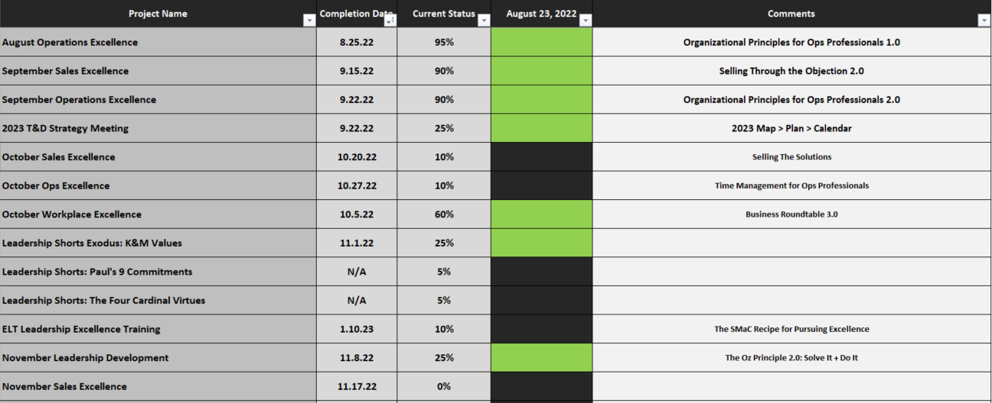

Monthly Communication Expectations
- In addition to weekly meeting updates, the Director of Training must submit monthly communication to keep the VPHR updated on training events, projects, and proposals. This is to be a higher-level overview and should be concise where possible. The intended result is to keep the right things top of mind, examine or re-examine certain items, analyze projects so that the ELT member is aware and aligned with what’s happening in their department, able to see trends, and ultimately to make better decisions by being more proactive.
- Below is an example of an acceptable monthly communication format, which can also be found:
\\file-a.kmtire.local\File Server\Training & Development\Shared\MISC\Monthly Communication.

- LEADERSHIP DEVELOPMENT:
Our next Leadership training is scheduled to go out on August 18th and will focus on managing with consistency. It will be delivered in video format with an accompanying digital workbook and training satisfaction survey. This Leadership training is a repackaged Operations Excellence training from July 2020. The following Leadership training is scheduled to be delivered on September 15th in video format and will be a repackaged Operations Excellence video from August 2020.

- WORKPLACE EXCELLENCE:
The next Workplace Excellence training goes out on August 18th in video format and focuses on the Power of Problem-Solving. The script was written specifically for this training audience and will include a digital workbook and survey. The following Workplace Excellence training goes out on September 15th and will also be in a video format, focused on The Power of Effective Communication.

- NEXT STEPS LEADERSHIP:
NSL2.0 live training was held on August 11th and focused on Change Management. With PTO and travel, the training group was small. Our next NSL2.0 training will be held on September 22nd and will focus on Building and Developing Effective Teams. We will be relaunching our “accountability groups” after this training, which will continue through their graduation in December.

- OPERATIONS EXCELLENCE:
August Ops Excellence training will be delivered on August 13th and focuses on leading with effectiveness. Our next Ops Excellence training will be delivered on September 10th and focuses on proactive organizational techniques.

- SALES EXCELLENCE:
August Sales Excellence training was delivered on August 6th and focused on effective communication. Our next Sales training will be delivered on September 10th and will focus on The Power of Problem-Solving, including a problem-solving process and framework.

- OTHER PROJECTS:
Working on comprehensive Training & Development SOP’s.

- PROFESSIONAL DEVELOPMENT: Q3 PLAN
(As of 8/12, all Q3 professional development objectives are on target)
- Finish 10x books and audiobooks and implement at least one action item from each into our training and development.
- Continue BOLD Training
- Become a “professional” at writing online training scripts and delivering training video content
- Complete at least 1x T&D-related course on Coursera or EdX
Global Leadership Summit

Training Overview
We currently conduct ongoing training for four distinct training audiences. Our Leadership Development training focuses on building leadership and management principles for our team of supervisors, Managers, and HR.

- Our Workplace Excellence training program builds capabilities and provides continuous improvement and professional development opportunities for our corporate office team.

- Our Operations Excellence training series is created for our warehouse management teams and focuses on building professional management skills. Finally, our Sales Excellence training series is created for our outside sales team and focuses on building broad professional selling and customer service skills.

- Additionally, our Next Steps Leadership program aims to provide opportunities for both high potential entry level and high potential supervisor level team members to develop new skills, expand skill sets, flourish in their current roles, and prepare them for the next step in their career with K&M Tire.

- The Director of Training should communicate proactively with each training audience via email to announce upcoming training, send out training invitations, and communicate optional pre and/or post-training work or reading. An overview of the training audiences is available on the F drive: \\file-a.kmtire.local\File Server\Training & Development\Shared\MISC\Training Audiences.xlsx.

- Finally, the Director of Training is also responsible for creating and delivering department-specific training on an as-needed basis and in conjunction with ELT members as well as delivering monthly in-person new employee orientation sessions for all new Delphos teammates.
More details about each specific training program are available in the following pages.

Leadership Development Training Program
Our Leadership Development training program is intended to build our bench strength, while exploring the skills, tactics, and principles that the most effective leaders and managers at K&M Tire utilize.

- Success looks like creating a path for our supervisors and managers to become more effective leaders with a specific focus on building effective teams. We will measure the success of our Leadership Development raining by evaluating our training satisfaction surveys and the Director of Training will calibrate progress towards stated objectives with the ELT.

- We conduct Leadership Development training in conjunction with our quarterly manager’s meetings because that is a relatively rare opportunity to gather most of our manager’s together in a single place for training, discussions, and meetings. Additional virtual training can be delivered as needed.

- Our preferred method of live training is to facilitate learning with a high degree of audience engagement. This can be accomplished through the effective use of audience engagement activities like role playing, internal or external videos to reinforce key points, audience handouts, etc. Additional thought can be given to pre-training prep work and optional post-training assignments or reading to help assist with audience comprehension.

Below is an example of an effective planning format for our Leadership training:
TRAINING PROGRAM | LEADERSHIP DEVELOPMENT
TRAINING TITLE | The Power of Effective Team-Building
TRAINING OBJECTIVE | To define what effective team building is, why it is important to K&M Tire, and to explore the underlying practices and principles that allow managers to build and develop effective teams at K&M Tire.
KEY TAKEAWAYS | To understand why effective teams are important to K&M Tire and to gain an understanding of how specifically supervisors and managers can build effective teams.
TRAINING AUDIENCE | Delphos supervisors and managers, Select HR, ROM’s, and RSM’s

Official Training Program Logo:


Training logos are helpful when creating training content and can be found:
\\file-a.kmtire.local\File Server\Training & Development\Shared\MISC\Sample Training Plan.docx on the F drive.

Workplace Excellence Training Program
Our Workplace Excellence training program is intended to connect our team with K&M Tire's Values while providing opportunities for professional development and exploring skills and principles for success.
- Success looks like building critical skills that improve effectiveness and increase efficiencies in our business.
- The process of creating our Workplace training begins with proactive quarterly discussions with the VPHR to ensure that our training topics are timely, relevant, and valuable. Once training topics are calibrated with the VPHR, the Director of Training creates and presents the training outline, which covers the strategy behind the training and how the training will help to move the organization and our teams towards what’s most important to the company. The outline also includes the specific topics that will be included in the training and enough detail to give the VPHR an understanding of the purpose of the training and what it will help to accomplish with the intended training audience.

Below is an example of an effective planning format for our Leadership training:
TRAINING PROGRAM | WORKPLACE EXCELLENCE
TRAINING TITLE | The Power of Effective Communication
TRAINING OBJECTIVE | To define what effective communication is, why it is important to K&M Tire, and to explore the underlying practices and principles that allow our team to communicate effectively through all communication medium and across departments.
KEY TAKEAWAYS | To understand what specifically effective communication looks like at K&M, to understand that owning our communication is a critical component of our job, and improving our communication is our collective responsibility as a team.
TRAINING AUDIENCE | All corporate office team members

Official Training Program Logo:
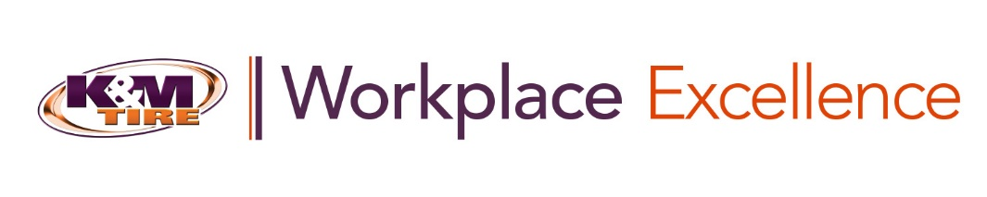

Preparing, Creating and Delivering a Business Excellence Training Module
In order to reinforce excellence and strengthen the impact of our training and development, the Director of Training may periodically create and deliver turnkey training solutions for K&M managers, directors and VP’s to train their teams on both hard and soft skills through virtual external training content.

- Step One: Initial Communication

- Prior to gathering or creating new training modules, the Director of Training (DT) should communicate with the VPHR.
  - The DT is to be clear on the ultimate purpose and how this training will reinforce excellence and deliver value to our supervisors and their teams.
  - This communication with the VPHR can be by phone, via email or in person.
  - The VPHR may have initial feedback, more information or better context than the DT on which training modules would be most effective and impactful.
- Step Two: Clarify Purpose of Training

- The DT must be clear on the ultimate Purpose of the training prior to gathering, creating and/or organizing training content and should keep the focus of the training specific and deliberate.
  - This is critical because of the sheer volume of training that is available to be gathered.
  - All training, specifically video-based training must be clear, concise and must aim at a clear and compelling predetermined objective.

- Step Three: Gather and Build Training Content

- In this stage, the DT is to gather and organize the training content. There is no shortage of excellent pre-produced training content from hundreds of possible sources of training.
- Part of the DT’s job is to seek out training materials with the ultimate goal of fulfilling our training and development mission of building the leading and most trusted team.
- Once training materials have been gathered, the DT is to organize them on the Sprout video hosting platform.
- Once videos are uploaded to Sprout, they should be moved to the appropriate training folder, edited, made password-protected, and added to a new playlist in Sprout.
- An optional next step would be to upload the videos and/or playlist to the intranet training portal.

- Step Four: Build in Audience Engagement

- Because here at K&M Tire, we train for results and action, it is simply not sufficient to expect our training audiences to passively watch training.
  - In many cases, this may be accomplished through creating a learning guide to help guide the training audience through the training and draw their attention to the most important key takeaways and action items.
  - This learning guide is to be organized in a clear, compelling and professional way and should include thoughtful and thought-provoking questions, aimed at helping the training audience to apply the training.

- Step Five: Go First

  - Before any Business Excellence training module goes live to a training audience, the DT is to complete the training first to ensure cohesiveness, clarity and professionalism.
    - It is simply insufficient to simply build, organize and deliver a training module without first completing it.
    - This is a critical step to ensuring that the training content does not detract form any of K&M Tire’s Values or primary points of focus.

- Step Six: Checkpoint communication

  - Once the training module has been created, the DT is to send the completed training module and all supporting learning materials to the VPHR before the training ships to the identified training audience.
    - Over time, the VPHR may set expectations that this step is optional. Unless and until that happens, the DT is to send all new Business Excellence training modules to the VPHR.
    - This can be accomplished via a clear and concise email with any requested calls to action or requests in the email.
    - This should be added as an agenda item for the following weekly meeting for discussion.

- Step Seven: Make it Turnkey

  - The DT’s role in our Business Excellence training program is to gather, build, organize and communicate the training. Not to lead the actual training. This critical distinction makes our Business Excellence training program highly scalable as K&M Tire and our training audiences continue to grow.
    - The DT is to create a single page communication to be delivered to the supervisor, manager, director, or VP who will take the lead on administering the training module to their team.
    - This may include a brief description of the training, a clear training objective, a brief biography on the trainer, tips for success aimed at helping the supervisor to effectively lead their team with the training and a list of PAQ’s (proactively asked questions).

- Step Eight: Deliver and Describe

  - Once the Business Excellence training module has been created, organized, approved, and tested, the DT is to deliver the Business Excellence training program.
    - This can be done individually with specific supervisors who have requested similar training or sent out via email to a group of supervisors.
    - This communication should clearly state the purpose, objective, and content of the training, along with instructions for how to access all learning materials.
    - Training documents can be hosted on the F drive or laded directly into the intranet training portal.

- Step Nine: Reinforce Excellence

  - Once the training module has been delivered, the DT is to periodically check back on all uploaded training content to ensure that it is being utilized effectively and otherwise look for continuous improvement opportunities.
    - This is to be done at least twice per year to ensure that all training is accomplishing its stated objective, to ensure that the training is actually being used, and to refresh training content where necessary.
    - The Dt is to check the engagement report on the Sprout website and this may be an opportunity to remind supervisors and managers that this training is available.
    - The DT should always be on the lookout for continuous improvement opportunities in all areas and with all training.

Operations Excellence Training Program
Our Operations Excellence training program is intended to build the leading and most trusted team of operations professionals in the U.S. tire industry through exploring management and leadership principles.

- Success looks like providing a framework and opportunity for top-performing operations professionals to develop and refine relevant skill sets.

- Because our Ops training audience is geographically located throughout the country, this video-based training is conducted virtually on a monthly basis. And because our warehouse management teams oftentimes work hours throughout the day and night, it is important that our Ops training is highly digestible and applicable. For this reason, we deliver Ops training as two relatively short videos delivered twice throughout the month.

- The Director of Training should maintain continuous communication with the VP of Operations, Director of Operations, and Regional Operations Support Manager to ensure that training remains aligned with their expectations and covers valuable and relevant training topics. Periodically, Ops training can include other members of our operations team on video to reinforce important training topics and to customize our training to this training audience.

Below is an example of an effective planning format for our Operations Excellence training:
TRAINING PROGRAM | OPERATIONS EXCELLENCE
TRAINING TITLE | Building High Performance Teams
TRAINING OBJECTIVE | To define what effective team building is, why it is important to K&M Tire, and to explore the underlying practices and principles that allow our warehouse management teams to build and develop effective teams at K&M Tire.
KEY TAKEAWAYS | To understand why building high performance teams is critical to K&M Tire and to explore how we can apply team-building tactics and principles to elevate our teams’ collective performance.
TRAINING AUDIENCE | Warehouse management teams, regional operations staff

Official Training Program Logo:


Operations Excellence Training SOP
Training Program Objective: To build the leading and most trusted team of operations professionals in the U.S. tire industry through exploring management and leadership principles.

- Step One: Annual planning and mapping process.

  - This process is to begin in early Q4 of the prior training year to identify training needs, select training topics, and prioritize training topics. Once training topics have been selected, the director of Training (DT) is to create a training calendar for the subsequent training year.
- This process is to include the DT, the Vice VPHR of Operations (VPO) and the Director of Operations (DO) and is to be conducted as an in-person discussion.
- The DT is to contact the VPO and DO at least three weeks in advance and select a meeting date and time that works well for all parties.
- The DT should come prepared to lead the meeting and direct the discussion, while leaving space and opportunity for the VPO and DO to contribute to the conversation while mutually selecting the most impactful and timely training topics.
- Once training topics have been selected and prioritized, the DT is to send the training calendar to the VPO and DO and this calendar is to be included in the master training calendar to be sent to the VPHR.
- This step is to be completed before December of the prior calendar year.

- Step two: Create and write training outline.

- With the primary training topic selected, the DT is to create a 1–2-page training outline to be sent to the VPO and DO for review and final approval.
- Sample training outline can be found here (include link to F drive document).
- At minimum, this training outline is to include the training title, format, scheduled shoot date, go-live date, objective, and key takeaways.
- This outline is also to include an outline with a clear opening, body, and closing, along with a training tool, which will be primarily utilized to train the audience on the selected training topic.
- The closing should restate the training objective, key training takeaways, include an audience call to action to apply the training material, and issue a go-forward challenge for the audience.
- As with all video training, care should be taken to write a timeless script devoid of references to current events or dates because this training will be viewed by K&M teammates will into the future.
- This step is to be completed approximately five weeks in advance of go-live date.

- Step Three: Present and discuss training outline.

  - Once the DT has written a comprehensive training outline, the draft outline should be delivered to the VPO and DO for their review, edits, and final approval.
- This can be accomplished in-person, email and phone, or via email only depending on travel schedules and availability.
- Emphasis should be placed on when and where the DT is requesting assistance from the VPO, DO, or any of their team members. Tor example, the ST may choose to periodically include the VPO and/or DO in the video to further reinforce the primary training objective and importance of the training with the training audience.
- After review and receiving feedback, the DT is to make all requested changes to the training objective and importance of the training with the training audience.
- This step is to be completed approximately four weeks prior to go-live training date.

- Step Four: Write training script.

- Once the training outline has been approved and finalized, the DT must write the training script that will be loaded into the teleprompter prior to filming.
- This is to be done in a Word document and should be devoid of formatting as it will be loaded into teleprompter software.
- Care should be given to write a clear and concise opening, interesting and intriguing body, and a closing with a clear call to action where necessary.
- Utilize the comment feature in Microsoft Word to denote where graphics (GFX) are being requested.
- Once script is completed, it should be sent to the Digital Production Specialist (DPS). The DT should then coordinate a date and time for filming and should reserve the filming/production/training room in Outlook.
- This is to be completed approximately four weeks prior to go-live date.

- Step Five: Film training.

  - Once the script has been written and loaded into the teleprompter software, the DT is to film the training with the DPS.
- The DPS is to have the filming room and equipment set up prior to the start of filming.
- The DT is to come prepared and rehearsed to deliver a clear, compelling, and actionable training session. We train for action, results, and behavior change.
- The DPS is to edit this training video in a lower resolution to be viewed strictly on a mobile device in order to minimize bandwidth usage and video load times.
- This is to be completed at least three weeks prior to go-live.

- Step Six: Prepare training video for distribution.

  - Once the DPS has filmed, edited, and produced the training video, the DT is to set up the video to be distributed to the training audience.
- This entails adding a title and typing in the training objective into the sprout website, which is used to host out training videos.
- Operations Excellence training videos should not require a password in order to limit the number of potential obstacles for our drivers. A password will be added later for information security purposes.
- A “call to action” can be included with a link to a short training survey if desired. Training satisfaction surveys are to be hosted on the Jotform website.
- This is to be completed at least one business day prior to go-live training date.

- Step Seven: Distribute training content to training audience.

  - Once the training video is set up for distribution, the DT should draft and deliver a professional and concise email directly to the training audience.
- This training is to be delivered via email to the warehouse manager email distribution list, preferably in the morning so as to give warehouse
This training is to be delivered via email to the warehouse manager email distribution list, preferably in the morning so as to give warehouse management team’s ample time to view and complete the training at their convenience.
- This email should include a link to the video URL, link to the digital learning guide (hosted on Jotform website), an actual PDF attachment with the learning guide (created in PowerPoint or similar program), and a deadline by which all training audience members must have this training completed.
      - Operations Excellence training is delivered on Thursdays and warehouse managers have until the end of the business day the following Wednesday to complete the training.
      - Audience members with PTO are exempt from the deadline, but should complete this training upon their return.

- Step Eight: Close the loop.

- Once the training has been delivered, the DT should prepare a “report out” to the VPO, DO, and the VPHR.
- The DT is to compile an engagement report once the training has been delivered and a reasonable amount of time has passed to allow the training audience to view the training. This report should at least include an attendance list, engagement overview form Sprout, and an organized summary of training satisfaction surveys. Note that surveys should not be anonymous.
- Approximately 10 business days after delivering the training, the DT should add a password to the training video on the Sprout website. This password should be changed each January, along with all training video content hosted on the Sprout website.
- This step is to be completed within 5 business days of delivering the training.

Sales Excellence Training Program
Our Sales Excellence training program is intended to build the leading and most trusted team of sales professionals in the U.S. tire industry through exploring principles and strategies to improve our culture of sales and customer service excellence.
Success looks like providing a framework and opportunity for top-performing sales professionals to develop and refine relevant skills sets.

TRAINING PROGRAM | SALES EXCELLENCE
TRAINING TITLE | The Power of Motivation
TRAINING OBJECTIVE | To explore the power of motivation and uncover what specifically motivates you to become an even more effective and successful sales professional.
KEY TAKEAWAYS | To recognize that although most results are not directly within the realm of our control, we are firmly in control of our motivation, to understand what motivates us, and to invest more of ourselves into our areas of greatest motivation.
TRAINING AUDIENCE | All outside sales team
Official Training Program Logo:


Sales Excellence Training SOP
Training Program Objective: To build the leading and most trusted team of sales professional in the U.S. tire industry through exploring principles and strategies to improve our culture of sales and customer service excellence.
- Step One: Annual planning and mapping process.

- This process is to begin in early Q4 of the prior training year to identify training needs, select training topics, and prioritize training topics. Once training topics have been selected, the Director of Training (DT) is to create a training calendar for the subsequent training year.
  - This process is to include the DT, the Vice VPHR of Sales (VPS) and is to be conducted as an in-person discussion.
- The DT is to contact the VPS at least three weeks in advance and select a meeting date and time that works well for all parties.
- The DT should come prepared to lead the meeting and direct the discussion, while leaving space and opportunity for the VPS and this discussion, while leaving space and opportunity for the VPS to contribute to the conversation while mutually selecting the most impactful and timely training topics.
- Once training topics have been selected and prioritized, the DT is to send the training calendar to the VPS and this calendar is to be included in the master training calendar to be sent to the VPHR.
- This step is to be completed before December of the prior calendar year.

- Step Two: Create and write training outline.

  - With the primary training topic selected, the DT is to create a 1–2-page training outline to be sent to the VPS for review and final approval.
- Sample training outline can be found here (include link to F drive document).
- At minimum, this training outline is to include the training title, format, scheduled shoot date, go-live date, objective, and key takeaways.
- This outline is also to include an outline with a clear opening, body, and closing, along with a training tool, which will be primarily utilized to train the audience on the selected training topic.
- The closing should restate the training objective, key training takeaways, include an audience call to action to apply the training material, and issue a go-forward challenge for the audience.
- As with all video training, care should be taken to write a timeless script devoid of references to current events or dates because this training will be viewed by K&M teammates well into the future.
- This step is to be completed approximately five weeks in advance of go-live date.

- Step Three: Present and discuss training outline.

- Once the DT has written a comprehensive training outline, the draft outline should be delivered to the VPS for their review, edits, and final approval.

- Emphasis should be placed on when and where the DT is requesting assistance from the VPS or any of their team members. For example, the DT may choose to periodically include the VPS in the video to further reinforce the primary training objective and importance of the training with the training audience.

- After review and receiving feedback, the DT is to make all requested changes to the training outline.

- This step is to be completed approximately four weeks prior to go-live training date.

- Step Four: Write training script.

  - Once the training outline has been approved and finalized, the DT must write the training script that will be loaded into the teleprompter prior to filming.
    - This is to be done in a Word document and should be devoid of formatting as it will be loaded into teleprompter software.
    - Care should be given to write a clear and concise opening, interesting and intriguing body, and a closing with a clear call to action where necessary.
    - Utilize the comment feature in Microsoft Word to denote where graphics (GFX) are being requested.
    - Once script is completed, it should be sent to the Digital Production Specialist (DPS). The DT should then coordinate a date and time for filming and should reserve the filming/production/training room in Outlook.
    - This is to be completed approximately four weeks prior to go-live training date.

- Step Five: Film training.

  - Once the script has been written and loaded into the teleprompter software, the DT is to film the training with DPS.
    - The DPS is to have the filming room and equipment set up prior to the start of filming.
    - The DT is to come prepared and rehearsed to deliver a clear, compelling, and actionable training session. We train for action, results, and behavior change.
    - The DPS is to edit this training video in a lower resolution to be viewed strictly on a mobile device in order to minimize bandwidth usage and video load times.
    - This is to be completed at least three weeks prior to go-live training date.

- Step Six: Prepare training video for distribution.

  - Once the DPS has filmed, edited, and produced the training video, the ST is to set up the video to be distributed to the training audience.
    - This entails adding a title and typing in the training objective into the Sprout website, which is used to host our training videos.
    - Sales Excellence training videos should not require a password in order to limit the number of potential obstacles for our drivers. A password will be added later for information security purposes.
    - A “call to action” can be included with a link to a short training survey is desired. Training satisfaction surveys are to be hosted on the Jotform website.
    - This is to be completed at least one business day prior to go-live training date.

- Step Seven: Distribute training content to training audience.

  - Once the training video is set up for distribution, the DT should draft and deliver a professional and concise email directly to the training audience.
    - This training is to be delivered via email to the outside sales email distribution list, preferably in the morning so as to give the outside sales team ample time to view and complete the training at their convenience.
    - This email should include a link to the video URL, link to the digital learning guide (hosted on Jotform website), an actual PDF attachment with the learning guide (created in PowerPoint or similar program), and a deadline by which all training audience members must have this training completed.
- Sales Excellence training is delivered on Thursday s and the outside sales team has until the end of the business day the following Wednesday to complete the training.
- Audience members with PTO are exempt from this deadline, but should complete the training upon their return.

- Step Eight: Close the loop.

  - Once the training has been delivered, the DT should prepare a “report out” to the VPS and the VPHR.
    - The DT is to compile an engagement report once the training has been delivered and a reasonable amount of time has padded to allow the training audience to view the training. This report should at least include an attendance list, engagement overview from Sprout, and an organized summary of training satisfaction surveys. Note that surveys should not be anonymous.
    - Approximately 10 business days after delivering the training, the DT should add a password to the training video on the Sprout website. This password should be changed each January, along with all training video content hosted on the Sprout website.
    - This step is to be completed within 5 business days of delivering the training.

Next Steps Leadership Program
Our Next Steps Leadership training program is intended to develop current supervisors and managers and to sharpen their skills while increasing their capacity for effectiveness. As of August 2022, this training program is postponed indefinitely. However, it can be resurrected at a later time to reach our team of high potential future leaders at K&M Tire.
- Our Next Steps Leadership program includes a 1.0 program intended for high potential entry level team members and is aimed at identifying and developing high potential team members to become future leaders at K&M Tire.
- Our NSL training program also includes a 2.0 program intended for high potential team members and supervisors and is aimed at providing a framework for individual development of high potential team members and supervisors with a focus on improving effectiveness and increasing individual capacity.
- Note that our Next Steps Leadership 2.0 program can replace or supplement Individual Development Plan training.
- To better understand the intention and planning behind this training program, more information can be found on the F drive and is linked in this document. Next Steps 1.0 \\file-a.kmtire.local\File Server\Training & Development\Shared\Next Steps Leadership\NSL 1\2019\NSL 1 Program Structure.docx and
\\file-a.kmtire.local\File Server\Training & Development\Shared\Next Steps Leadership\NSL 1\2019\NSL 1 Program Summary.docx.
Next Steps 2.0 \\file-a.kmtire.local\File Server\Training & Development\Shared\Next Steps Leadership\NSL 2\Next Steps 2 Program Summary.docx.

Below is an example of an effective planning format for our Next Steps Leadership training:
TRAINING PROGRAM | NEXT STEPS LEADERSHIP
TRAINING TITLE | Critical Thinking & Problem Solving
TRAINING OBJECTIVE | To define what critical thinking is, why it is important to K&M Tire, and to explore the underlying practices and principles that allow team members and managers to think critically and effectively solve problems at K&M Tire.
TRAINING AUDIENCE | High potential team members and supervisors

Official Training Program Logo:
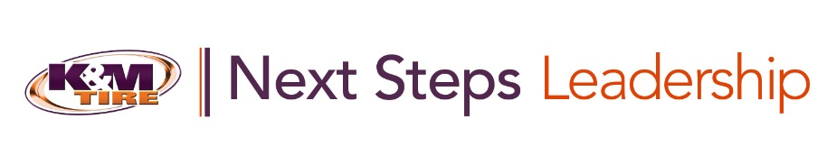
Additionally, other tactics that can and have been used in conjunction with our Next Steps Leadership training program include formal mentoring, informal coaching, Mastermind meetings, and other tactics. Mastermind meeting values are \\file-a.kmtire.local\File Server\Training & Development\Shared\Next Steps Leadership\NSL 2\2020 Accountability Group Values.pptx and help to drive effective Mastermind or “Accountability Group” meetings.

Driving Excellence Training Program
Our Driving Excellence training program was launched in February 2021 and is intended to connect our team of route drivers to K&M Tire’s Purpose.
This is a micro-training program, intended to be consumed in 90-120 second bites via a mobile format. As of August 2022, this training program is postponed indefinitely. However, it can be quickly resurrected as a means to communicate directly with our team of driver’s companywide.
More information about this training program can be found on the F drive
\\file-a.kmtire.local\File Server\Training & Development\Shared\Driving Excellence\2021 Proposal.docx
and below is our official training program logo:


Business Excellence Training
Training Program Objective: To strengthen the Impact of our live and digital training and reinforce Excellence throughout the organization by organizing and delivering professional external training content.
- Step One: Searching for external training content.
The DT should continually be on the lookout for remarkable training content from external sources as well as building and delivering internal training content. This may be from sources like Fred Pryor, Ken Blanchard, and Harvard Business Review. Other times, it may be from webinars, live training conferences, and even YouTube.

- Step Two: Identifying external training content.
When an external training program has been identified, it may be considered to be included in our Business Excellence training program. In the event that content can be pulled from YouTube using software similar to 4K Video Downloader, the training video file can be uploaded to Sprout as a private video so that only those with the training link can access the training video.

- Step Three: Uploading training content.
On the Sprout website, standalone training content can be simply uploaded as a single training video file. If there are multiple shorter training videos in a series, they should be uploaded and added to a training video playlist. Playlists can be viewed and created from the “Playlist” button in the top tool bar on the Sprout website.
  - When creating a playlist, training content can be customized by adding an intro and outro video clip, along with short video clips that encourage the audience to pause the training so they can follow along in the accompanying learning guide.
  - Intro, outro, and “pause” video clips are already uploaded to the Sprout website and can be reused in new playlists or new intro and outro video clips can be shot and produced as-needed.

- Step Four: Embedding training content.
Once the training video has been uploaded to Sprout, it should be embedded into the intranet under the “Business” page. This process should include adding the embed code, video title, video tags, clarifying what the objective of the training is, and a learning guide can and should be attached.

- Step Five: Creating the audience learning guide.
Because we train for action and results, all (or at least most) Business Excellence training modules should include an accompanying learning guide so that audience members can apply the training as they view it.

- Step Six: Updating and uploading the leader (facilitator) guide.
Business Excellence training modules are intended to be “turnkey” training solutions that managers (and up) can facilitate for their teams. For this reason, the leader guide should be uploaded to the intranet for all Business Excellence training modules. This document has already been created, but should be periodically updated approximately once per year.

- Step Seven: Vetting and testing the new training content.
All training content should be vetted by the DT and/or the MTD. Optionally, training content can be “tested” by asking a specific manager or two to facilitate the training for their team and then report back with suggested improvements to ensure that all Business Excellence training modules are valuable for other managers and teams throughout the company.

- Step Eight: Awareness and promotion of training content to ensure usage.
To ensure that our team is utilizing our Business Excellence training program and content, awareness is a prerequisite. The DT should ensure that the MTD is aware of all new training content uploaded to the intranet so that they can recommend the training on an as-needed basis. The DT may choose to periodically mention specific training during live training events, the DT can request that the associate director of communications send out communication about new training content, and the content itself is also searchable on the intranet by keyword.

Department-Specific Training
Our department-specific training is intended to address specific, measurable gaps between department needs and current department skill sets and capabilities. There is no calendar for department-specific training and it is not a continuously running training program.
- By remaining connected to and aligned with ELT members, the Director of Training should continually look for opportunities to address skill gaps with training where possible.

- When a gap exists, the Director of Training should ensure that training is a viable option to close skill gaps with both the VPHR and the relevant ELT member(s). At that point, the Director of Training should communicate closely with the ELT member to uncover underlying needs, create a training plan, and remain in communication with that ELT member to ensure that training initiatives remain aligned with the stated objectives.

- After the training, the Director of Training should provide a brief training summary to the ELT member and also with the VPHR.

New Team Member Orientation
Our Delphos new employee orientation sessions are intended to properly and successfully orient and begin onboarding new Delphos team members. These sessions are typically one hour in duration and are held once monthly from 4-5pm. The Director of Training is responsible for coordinating with HR to collect a list of new team members who have joined the company since the last orientation session and then to communicate with the new employees’ manager to ensure that all new team members are in attendance.
- Orientation sessions should begin and end on time as some new team members will be finishing up a long day of work whereas some team members are beginning their shifts. The Delphos orientation session is PowerPoint-based for the sake of consistency and thoroughness. However, successful orientation sessions are engaging and participative with the audience.
- These orientation sessions are a golden opportunity to effectively communicate K&M Tire’s story, our heritage, what we do, how we do it, and why we do what we do. Successful orientation sessions successfully connect the audience to K&M Tire’s Purpose as an organization and convey not only the benefits that accompany working for K&M Tire, but also communicate the opportunities for advancement that are available within the company for those who excel in their current roles, demonstrate a consistently positive and constructive attitude, and are interested and capable in taking on additional responsibilities in the future.
- The Director of Training may be involved with periodically updating our New Employee Orientation video for non-Delphos employees, which is located: https://kmtire.vids.io/videos/ac9cd6bb191ce5c725/2021-new-team-member-orientation and continually improving our Delphos new employee orientation process, which is located: \\file-a.kmtire.local\File Server\Training & Development\Shared\Onboarding

New Team Member Orientation SOP
Objective: To properly and effectively onboard K&M Tire’s newest teammates into our company, culture, and team. To connect our newest people to K&M Tire’s Purpose and to explain our core business, our company heritage, and team member benefits.

- Stage One: Overview

  - Our New Team Member Orientation (TMO) is intended to effectively connect our newest team members to K&M Tire’s Purpose.
- TMO is delivered by the Director of Training (DT) in a live format in the Delphos training room.
- The desired audience for this is all new teammates.
- TMO is delivered once per month from 4:00 – 5:00p in the training room for the sake of consistency.

- Stage Two: Audience

  - TMO includes all new Delphos teammates. From time to time, we may also rehire certain individuals. If a period of twelve (12) months or more has passed that the person has not been employed by K&M and rejoins our team, they are to be included in TMO.
- Prior to TMO, the DT should request a list of all new Delphos teammates from the HR department, along with their role, hire date, and supervisor.
- Under normal circumstances, it is ideal to keep the audience to a limit of 12 individuals. If there are more than 12 in the audience, it is best to conduct a second TMO session.

- Stage Three: Initial Communication

  - Once the DT has obtained a list of all new Delphos teammates, the DT should communicate with the team members’ immediate supervisor.
- The DT should first schedule the training room in Outlook to ensure that the room is available. This can and should be done up to 90 days in advance.
- Additionally, the VPHR may choose to greet all new team members towards the beginning of each TMO session and will want to know the date and time of each TMO session in advance.
- Once the Outlook calendar event has been created, the DT should forward the invitation as an iCal attachment within Outlook to all new team member supervisors with the date and time of the TMO session and a list of all new team members.
- The DT should request confirmation from each supervisor that their new teammates will be in attendance for the TMO session. This may require reminder communication.

- Stage Four: Preparation

  - The DT should prepare the training room and also the orientation session training is advance.
    - This TMO session will be among the first experienced our newest team members have with K&M tire and is a remarkable opportunity and responsibility to convey connection, community and professionalism. This is an opportunity to engage our team and should be treated as such.
    - The DT should give thought to the setup of the room to maximize audience engagement during the TMO session.
    - Each audience member should receive a physical learning guide to help them follow along, which can be found here.

- Stage Five: Reminder Communication

  - Because our supervisors are busy and scheduling new teammates can require advanced notice, a best practice is to send a reminder email to all supervisors approximately 24 hours in advance of the TMO session.
    - If the VPHR is planning to attend the TMO session, she may appreciate a reminder email as well.
    - This also creates a touch point for the DT to confirm with the supervisors which audience members will be in attendance for the TMO session.

- Stage Six: Delivery

  - This is one of the best opportunities anyone at K&M Tire will have to excite and engage our newest team members with K&M Tire. TMO delivery should be delivered with enthusiasm.
    - The DT should periodically engage with the audience and challenge them to contribute their own key takeaways and to answer questions from the learning guide.
    - Periodically, the DT should update the orientation presentation as needed.

- Stage Seven: Close the loop

  - Once TMO has been delivered, the DT is to track attendance, update the master attendance document located on the F drive here, and coordinate with the HR Department on who was not able to participate in the live TMO so that they can view the orientation video here.
    - This step is critical to ensure that we are properly tracking all new teammates and their participation with our TMO process.
    - HR is responsible for tracking non-Delphos teammates and their completion of our new team member orientation video.

- Stage Eight: Continuous Improvement

  - As with all training programs and SOP’s, the DT is to continually look for areas of improvement in process, delivery, and professionalism.
    - For example, the orientation presentation, orientation videos, audience learning guide, and process should be evaluated for areas of improvement on a regular bases as our business evolves.
    - When significant changes are made to the orientation session, the DT should ensure that the VPHR and Director of HR are both aware of significant changes only.
    - A best practice is to make incremental improvements when needed and evaluate the entire TMO process at least once per year for major changes or improvements.

Virtual Training SOP’s
- Our virtual training initiatives have the power to connect our team who are located throughout the country at all K&M locations. When delivering training by video or webinar, extra thought and care should be given to appearance and communication tactics.
- Below are a few helpful reminders for the trainer when preparing to deliver virtual training:
    - Don’t forget to smile!
    - Practice your script beforehand.
    - Watch forehead glare.
    - Bring flat water with you.
    - Warm up your vocal cords and facial muscles.
    - Double check your appearance before recording.
    - Wear a K&M-branded shirt.
    - Remove your watch.
    - Emphasize a warm introduction.
    - Show the palm of your hands near the intro.
    - Don’t forget to slow down.
    - Check your cadence to keep it interesting.
    - Adjust your tone to the message.
    - Use purposeful gestures to emphasize yourself.
    - Large hand gestures get cut off in post.
    - When you stumble, shake it off.
    - When you need a break, take 5.
    - When directing to digital workbook, point up with left hand.
    - Use props where appropriate to reinforce something important.
    - Use a single 2.7 second silent pause for effect.
    - Emphasis a meaningful and powerful closing.

- When delivering training virtually, communication tactics are relatively limited in comparison to delivering live training. Therefore, extra thought must be given to underlying communication principles, including cadence, tone, and vocal timbre. For this reason, warming up is a critical function to delivering successful virtual training.

  - Below is an example of an effective warm-up vocal practice:
    - Eat each green pea. Aim straight at the game. Ed said get ready.
    - It is in Italy. I tried my kite. Oaks grow slowly.
    - Father was calm as he threw the bomb on the dock.

    - VIRTUAL TRAINING SOP’S (CONTINUED)

    - An awed audience applauded Claude.
    - Go slow Joe, you're stepping on my toe.
    - Sauce makes the goose more succulent.
    - Up the bluff, Bud runs with the cup of love.
    - Red led men to the heifer that fell in the dell.
    - Maimed animals may become mean.
    - It's time to buy a nice limeade for a dime.
    - Oil soils doilies.
    - Flip a coin, Roy, you have a choice of oysters or poi.
    - Sheep shears should be sharp.
    - At her leisure, she used rouge to camouflage her features.
    - There's your cue, the curfew is due.
    - It was the student's duty to deliver the Tuesday newspaper.
    - He feels keen as he schemes and dreams.
    - Much of the flood comes under the hutch.
    - Boots and shoes lose newness soon.
    - Ruth was rude to the youthful recruit.
    - Vivid, livid, vivifying. Vivid experiences were lived vicariously.
    - Oddly, the ominous octopus remained calm.
    - The pod will rot if left on the rock.
    - Look, you could put your foot on the hood and push.
    - Nat nailed the new sign on the door of the diner.
    - Dale's dad died in the stampede for gold.
    - Thoughtful thinkers think things through.
    - Engineer Ethelbert wrecked the express at the end of Elm Street.
    - Unique New York, unique New York, unique New York.
    - A big black bug bit a big black bear.
    - She sells seashells by the sea shore.
    - Peter Piper picked a peck of pickled peppers.
How much wood could a woodchuck chuck if a woodchuck could chuck wood?

Digital Content Hosting and Management
We currently utilize a video hosting platform called Sprout to host our training videos. The site works well and should be continuously evaluated to ensure it remains capable of delivering the capabilities we require to effectively reach our virtual training audiences.

- Once the Digital Communications Specialist uploads the final video file to Sprout, the Director of Training should prepare the video for distribution to the training audience. This process should include adding a video description, video tags, making the video password-protected, adding lead capture to ensure that engagement can be tracked, and adding a mid-video and post-play call to action. These CTA’s can include links to the digital training workbook and the training satisfaction survey.

  - Below is an example of what this process looks like within the Sprout video platform and here is a video-based SOP for how to effectively utilize the Sprout Video platform:
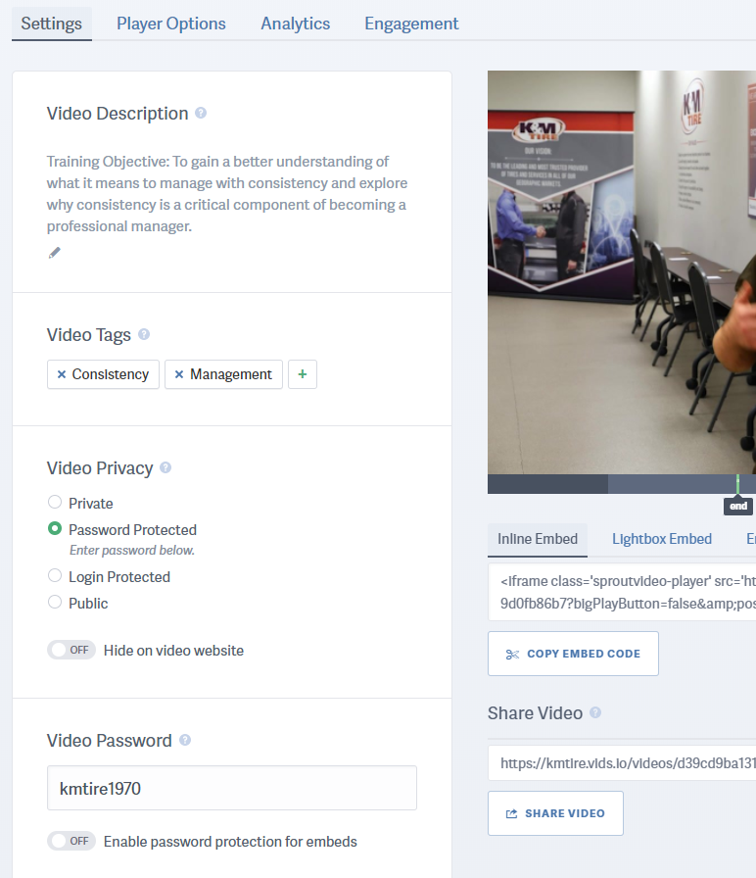

Training Satisfaction Surveys
Training satisfaction surveys are one of the most consistently reliable methods of gaining feedback directly from training audiences and should be used consistently to gauge audience engagement.
- We have used the SurveyMonkey.com platform in the past, but now use a service called Jotform, which allows you to create surveys and also digital training workbooks. There are hundreds of options and the platform works well for our purposes. Once on the Jotform website, start by clicking the “create form” button and then the site will walk you through the process of creating a new or copying an existing survey.
- When conducting live training, the Director of Training can email a link to a digital survey to the training audience directly after training while the training and information is still fresh in their minds. When conducting virtual training, the satisfaction survey can be included in the training delivery as either a separate link or can be built into the training workbook/learning guide where appropriate. With few exceptions, nearly all of our training is followed by an audience satisfaction survey.
- Below is an example of a training satisfaction survey, along with the survey questions we have recently asked, such as overall quality of training, training clarity, how actionable the training was, and whether or not the training accomplished the stated objective. Additionally, this survey is an excellent opportunity to ask the audience what else they would be interested in learning about in the future and can ask the audience for their advice or input on how to improve our future training. This is an important part of the continuous improvement process. Here is a video-based SOP for how to effectively utilize the Jotform platform.
- The Jotform website makes it easy to pull survey results as a PDF or into an Excel document and results can be shared with the VPHR and other members of the ELT afterwards to convey training content, feedback from the audience, and to help ELT member’s spot opportunities to reinforce important training points with their teams.
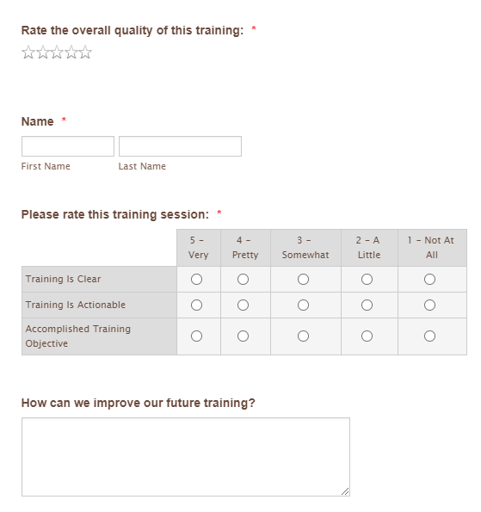

Continuous improvement Initiatives
In support of our company Mission of continuous improvement, the Director of Training should be at or near the forefront of helping to identify opportunities and lead continuous improvement initiatives.
- Our Mission of continuous improvement in all areas is to be lived and acted upon and not simply memorized and repeated. Our Mission of continuous improvement must include all of our training programs and initiatives.
- The Director of Training must pay careful attention to offer constructive recommendations in the periodic training satisfaction surveys and use excellent judgment to continually evolve and improve our training from one training session to the next.
- Additionally, the Director of Training Should invest some time periodically to understand new advances in the field of training, learning, and employee development. This can be done as needed through participation in leadership, training, industry conferences and by taking advantage of resources made available to K&M through our membership in the Association of Talent Development (www.td.org).
- If K&M Tire is to achieve our broader Vision of becoming the leading and most trusted provider of tires and services in all of our geographic markets, we must achieve our training Vision of building the leading and most engaging training and development program in the U.S. tire industry. As of August 2020, we have not yet achieved their Vision but are well on our way to achieving both ultimate goals.
- As with all leaders at K&M, the Director of Training & Development should continually look for opportunities to standardize processes and create new SOP’s where necessary and approved by the VPHR. Standard Operating Procedures or SOPs are critical to the success of the company.
- This Training & Development SOP should be continually reviewed and updated where necessary and approved by the VPHR. This should be done on an as needed basis.
- Additionally, we have implemented a team suggestions program, which offers a structured opportunity to gain new ideas or opportunities directly from our team throughout the company. This program exists digitally on the intranet and allows K&M team members to submit either or both suggestions and questions directly to top management. This program is administered by the Director of Training.
    - The DT is to pull suggestions from the intranet on at least a weekly basis. This can be done by clicking on the “Run Report” button, on the intranet (illustration is below). The DT is to conduct some initial research on the suggestion prior to bringing it to the VPHR, which can typically be done during regularly-scheduled weekly meetings.
    - There may be times when it makes sense for the DT to bring a question or suggestion directly to another ELT member and then include that suggestion or question on the weekly meeting agenda so the VPHR is aware of the question or suggestion.
    - All communication should go back to team members through the DT to ensure that there are no breakdowns in communication and to ensure that the entire K&M team understands that their voice matters and their questions and suggestions are being evaluated and considered.
    - The DT may work with the associate director of communications to periodically and continually send out reminders to the K&M team.

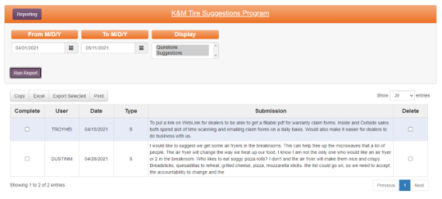

SOP For Working with A Freelance Professional
- Step One: Director of Training (DT) films training in production room.

- This will require production room and film equipment setup by the DT.

- Upon completion, the DT is to save the “master” (original) audio and video files to T&D Shared folder on the F drive.

- This is to be completed approximately 4-5 weeks in advance of training go-live deadline.

- Step Two: DT delivers audio and video files, along with all required assets to freelance video producer.

- This can be accomplished either on a USB drive or a cloud service like Google Drive or Dropbox.

- At minimum, this step must include all audio and video files, along with music files and logos.

- This is to be completed approximately 4-5 weeks in advance of training go-live deadline.

- Step Three: Freelance video producer edits training videos.

- Professional freelancer is to own or have access to their own hardware and software necessary to produce professional-quality video content.

- K&M Tire is not responsible for additional costs associated with renting production equipment or software unless prior agreement and approval by the DT and the VPHR.

- This is to be completed between 2-5 weeks in advance of training go-live deadline.

- Step Four: Freelance video producer submits a draft video for approval by the DT.

  - This can be delivered as a private video link on Sprout.
    - Note: you Tube is not a suitable solution to deliver a draft video.

  - This can also be accomplished via a cloud service like Google Drive or Dropbox.

  - This is to be completed at a minimum of eight (8) business days prior to training go-live deadline.

- Step Five: The DT is to approve or make necessary edits and resubmits video file(s).

- Approval or edits must be delivered in writing to the freelance professional.

- This can be accomplished via email and also a phone call where necessary.

- This is to be done as soon as possible so the freelance professional can make required changes prior to the training go-live deadline.

- Step Six: Freelance professional makes required edits and resubmits video files(S).

- Approval or additional edits must be delivered in writing to the freelance professional.

- This can be accomplished via email and also a phone call, where necessary.

- This is to be completed at least one full business day prior to training go-live deadline.

- Step Seven: The DT uploads and prepares training video for distribution to training audience.

- All produced video content is to be uploaded to the Sprout website. The content should be password-protected, require a first and last name to view the content, and should include a clear training objective.

- Training video should be embedded into intranet training portal and prepared for distribution, including optional learning guide.

- Step Eight: Upon completion and final approval, freelance professional is to submit an itemized invoice for payment.

- All costs must be pre-negotiated between the DT and the freelance professional and require prior approval by the VPHR. K&M Tire will not pay invoices that have not received prior approval from both the DT and VPHR.

- Invoice is to be submitted to the DT and then forwarded to the AP Supervisor as soon as possible.

- Invoice must include freelance professional business or personal name, address, full itemization, line-item subtotals, and grand total.

- If we have never worked with this freelance professional before, we will also need a completed W9 form.

- Step Nine: AP department submits payment.

- This will be done via physical check to be delivered via USPS. All payments are issued within 10 business days.

- Freelance professionals who earn more than $600 per tax year will receive a 1099 tax form.

CG Shorts
Purpose: To connect all K&M team members in all K&M locations to our company Culture of Trust, Respect, Ownership, Family, and Results. Because if it is to be, It’s up to me.
Objective: To ask the right questions and listen to our team and their ideas. Because our customer experience will never exceed our employee experience.
Audience: All K&M Tire Team Members
Format: 1.5-3.5-minute digital videos
Executive Summary: In support of our company Vision, Mission, Values, and Culture, the President will write, film, and deliver a short monthly video series to be distributed to the K&M team. This program will be referred to as “K&M Shorts” or another name TBD. This short video series will serve to reinforce in-person warehouse location visits by the CEO and President and will serve as a communication medium for our entire team to hear regularly and directly from our most senior leadership.
- This video series will be owned by the President and will be supported by the CEO, Director of Training, and Digital Communications Specialist. Over time, this series could include other members of the ELT at the President’s discretion. The President will take the lead on monthly in-person location visits and will be responsible for writing video scripts focusing on building K&M Tire’s company Culture.

- Culture is defined as a shared set of values, goals, attitudes, and practices that make up an organization. K&M Tire’s Culture is defined by Trust, Respect, Ownership, Family, and Results.
- Over time, this series may include success stories from K&M locations that reinforce and reward ideal behaviors. For example, managers who engage in professional development opportunities and then take action to serve their teams at a higher level or managers who take the lead on initiatives that operationalize our Mission and/or company Values.

- The President will personally monitor and lead a relaunched employee suggestions program, the result of which may be shared in these monthly videos at the President’s discretion. Because to feel like family, we must know our team and they must know us. Because we care and we value their ideas.

- These short videos will be written, filmed, produced, and distributed monthly. The Director of Training will work with the president to schedule these in advance to accommodate schedules.

- These short videos will be delivered in a concise, direct, and authentic way with limited video production and editing.

- Videos will be sent out via email to all K&M team members directly from the President on Paylocity. They can be shared on warehouse and breakroom TV’s. The Director of Training will be responsible for ensuring that all videos are properly hosted, labeled, tagged with keywords, and available to all K&M team members in perpetuity.

- These videos can also be linked via QR code in the monthly K&M newsletter.

- Success looks like: All K&M team members are clear on what K&M stands for and fully bought into our company Culture of Trust, Respect, Ownership, Family, and Results. K&M team members collaborate with one another instead of competing with each other. We prioritize establishing mutual trust as the foundation for effective working relationships throughout the organization. All K&M team members are clear on expectations, aligned around our Culture, and are professionally challenged, but comfortable and content.

Quote of the Week
The purpose of the Quote of the Week is to provide the K&M family an inspiring and motivating quote to kick start each week and must align with K&M Values.
- Talent Development researches, finds and prepares the Quote of the Week.

  - The weekly quote is communicated by email to company by Talent Development. The email is sent out to the company email list. Each quote is set up to go out weekly, every Monday morning before 8:30am. The body of the email should explain how these tie to K&M’s Mission, Vision and Values.

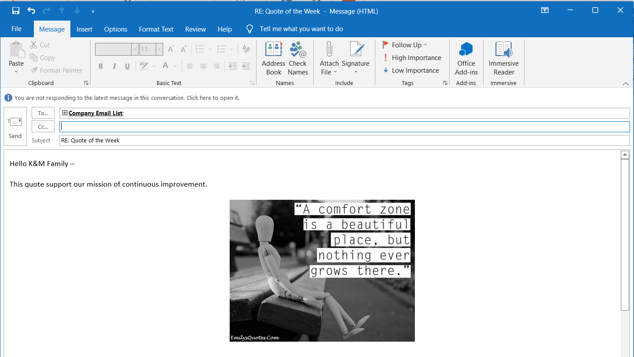

Word of the Month

The purpose of the Word of the Month is to be a source of motivation and rally the team around a word or theme that gives them better understanding to who we are. This can be key words in our Mission, Vision and Values or it can be key words that describe how we do things at K&M (example words: GRIT, GRIND, RESILIENCE).
- Talent Development completes the Word of the Month by the 15th of the month. In selecting the Word of the Month, it must:

- Support our vision, mission and values and what we stand for.
- It can include or tell a story.
- It can include a picture.
- It can explain the word and what it looks like in action.

- Word of the Month is emailed to the Administrative Assistants Department.
- Admin will print and send out the 1st of every month thru transfer to all warehouses and will email it out company wide.
- Admin will post flyers:

- In Delphos warehouse on We are K&M Tire board
- All bathroom bulletin boards
- All breakrooms
- By the purchasing and pricing printers

- Word of the Month will be showcased in the monthly newsletter.
- Word of the Month will be saved at F:/Training&Development/Public/WordoftheMonth
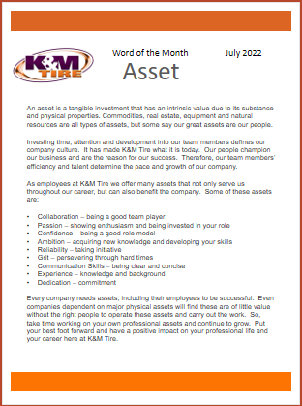

Degreed

Degreed Instructions on Set-Up SOP – For Talent Development (Admin)
Degreed is a learning platform used in the development of skills using business articles, videos, podcasts and other means of media to educate employees. Degreed connects learning and career growth to business opportunities through one single, fluid skill-development experience. K&M Tire uses this platform for development of individual employees who may be focusing on one or two specific skills.
- Setting an Employee Up on the System

- Degreed is administered through a company call Tractus. Tractus is a subsidiary that takes care of small to medium-sized companies. You can find this spreadsheet in the ADD USERS feature shown on the next page of this SOP. The columns in Red must be filled out for the document to be uploaded correctly. The rest of the columns can be filled out if you want extra information attached to that particular employee

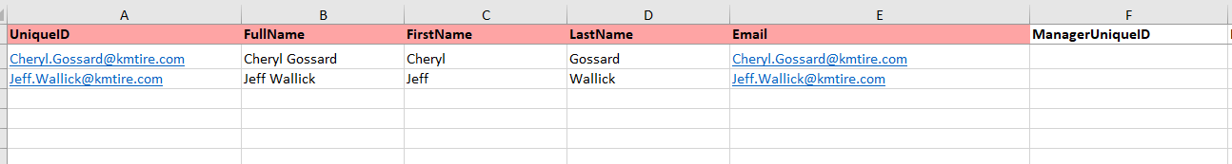

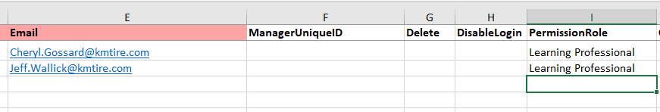
- All employees will be labeled a Member as a default, which offers limited permissions on the learning system, unless otherwise determined on the spreadsheet. Employees can be labeled as a Member, Learning Professional or Admin. TD and VP-HR/TD are the Admins. Any other employee is either a Member or Learning Professional.

- Once the spreadsheet is filled out it needs to be saved as kmtiretractus_User_File_yyyymmdd Once the spreadsheet is filled out it needs to be saved as kmtiretractus_User_File_yyyymmdd including the date that this document is being uploaded, for example kmtiretractus_User_File_20211020.

- To upload this document, you must be logged in as Manage K&M Tire by clicking on the 4-box icon in the upper right corner of the Admin home page and click on Manage K&M Tire. Only the Admin has the rights to add members

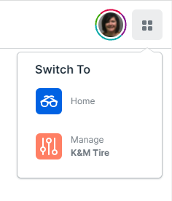

- Then click on the File Upload at the top of the page.

- Then click on Select in the Add Users box.

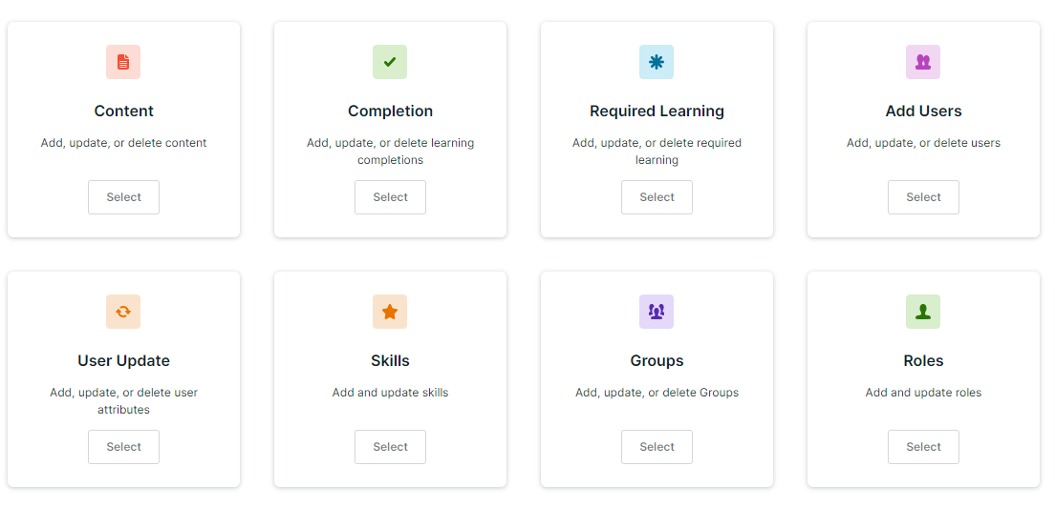

The next page shows the Template Instructions including a link to the form if needed. On this page you will just click next if you have already filled out the spreadsheet and saved it.

- The next page shows the Template Instructions including a link to the form if needed. On this page you will just click next if you have already filled out the spreadsheet and saved it.

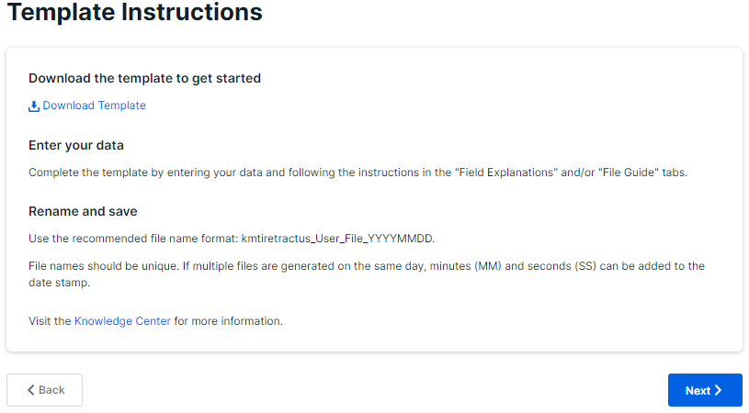

- Click on the large box in the center of the page that says Drag and Drop or Click to Upload to find the saved file.

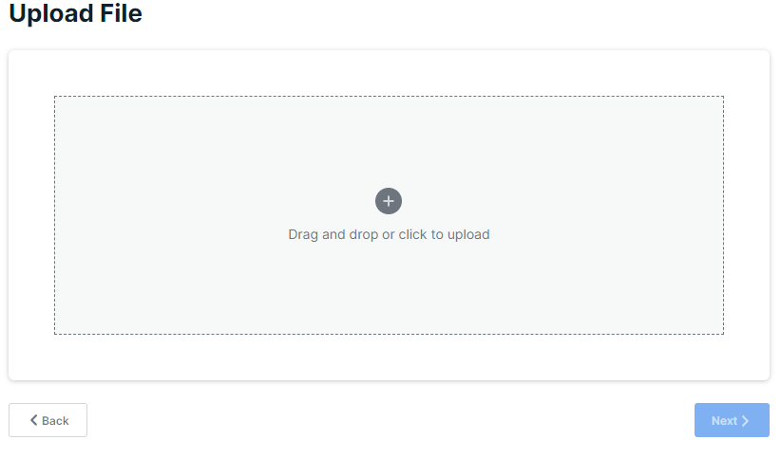

- Your file will pop up, click on the appropriate file and then open.

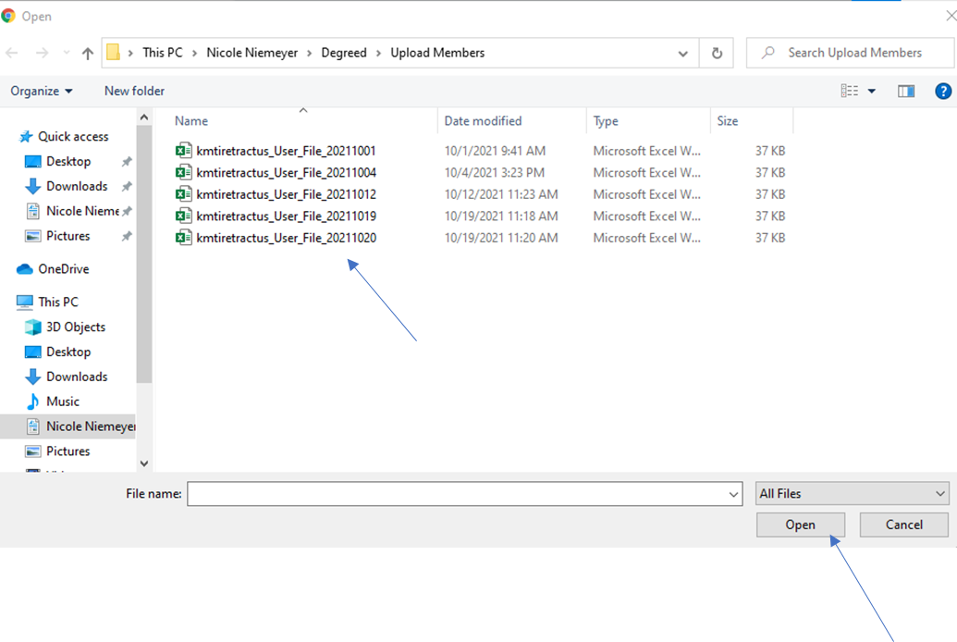
- Then click next. This file is now uploaded.

- Degreed has prepopulated content, pathways and plans. As the Admin, Talent Development can upload outside content such as articles found on the internet and intranet, videos, podcast, blog posts, infographics, etc. This content can be added or made into a pathway or just uploaded as content that can then be searched by the skill(s) assigned to the content.

- Uploading Content

  - To upload content, you must be signed into Manage K&M Tire. Do this by clicking on the 4-box icon in the upper right-hand corner and click on Manage K&M Tire.


  - Click on Catalog at the top.

  - Then go to the article and copy the URL by highlighting the URL and then right click your mouse. A menu will pop up. Click Copy.
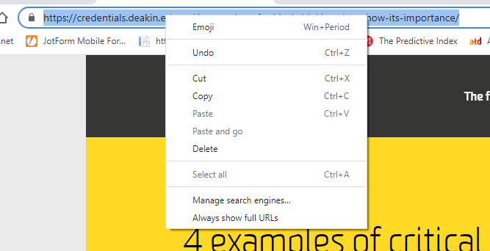

  - Go back to Degreed and click on Add Content on the Catalog page.

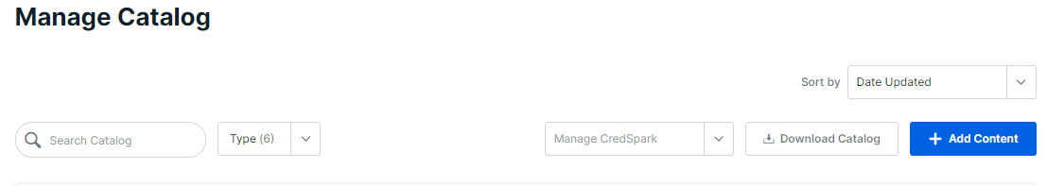

  - A box pops up that says Content Type. Click on the drop box that says Choose Content Type and click on the type of content you are uploading.

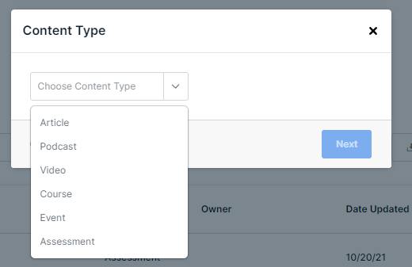

  - Then paste the URL from the article and click next.

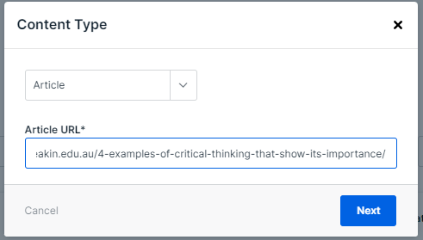

  - The box will then expand. You will then type in the Title of the Article in the Title box and Enter Skills that align with the article in the Skills Box. Then scroll down and click Save Changes

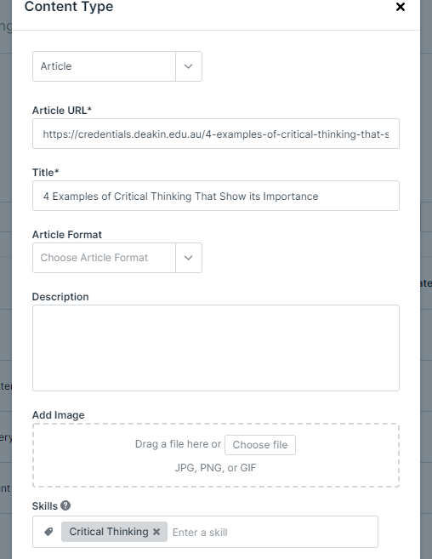

  - The article will then show up in the catalog. At this point you can just leave it as content that can be searched by the assigned Skill or add it to a Pathway.

- Adding External Content to a Pathway

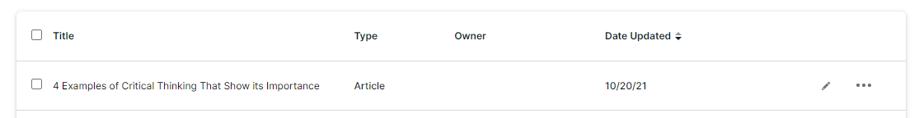
  - After adding external content to the Catalog, you can add that Content to a Pathway by clicking on the 3 dots on the right-hand side of the name of the Content that you want to add to a Pathway.

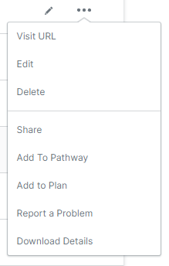
  - A menu box opens up. Click Add to Pathway.

  - An Add to Pathway box opens up. Click on drop down box and a list of the most recent Pathways you have been working on are listed. Click on the title of the Pathway you would like to add the Content to.

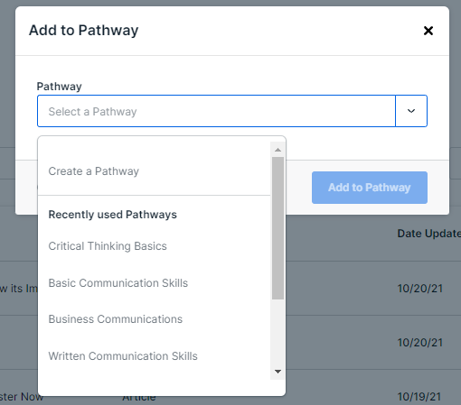

  - Then click on the next drop-down box and click on the section of the Pathway that you would like to add the Content to. Then Click the Add to Pathway button.

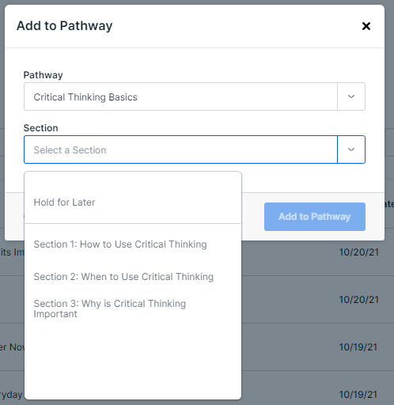

- How to Make a Pathway

  - After logging into Degreed click on Profile on the top of the Home Page.

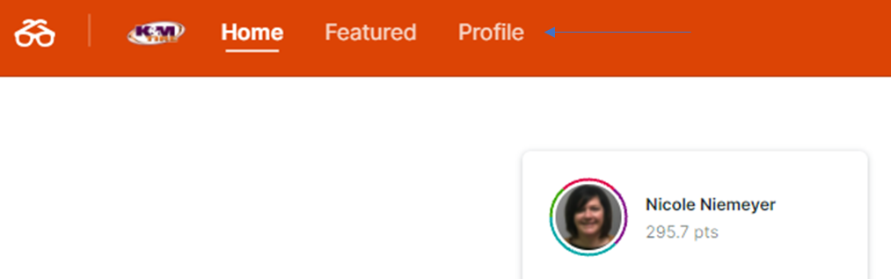

  - This will open up your personal dashboard. Click on Pathways

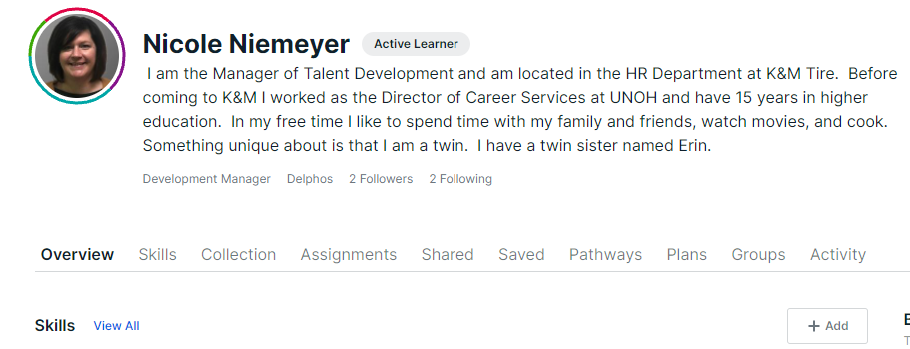

  - This page will show Pathways you are following, completed and authoring. This is where you start a Pathway. To do this scroll down until you find the Authoring section then click on Create a Pathway.

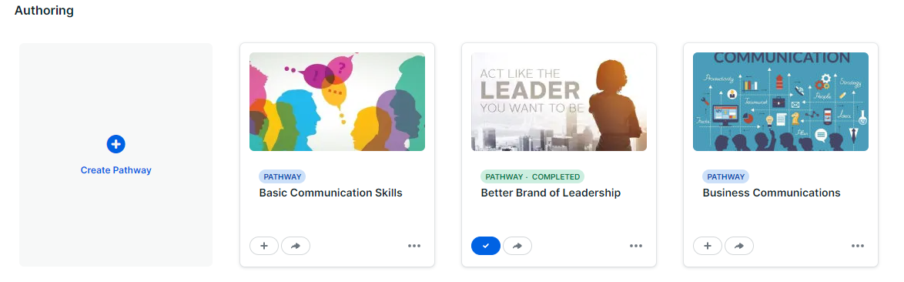

  - A box will pop up. You can make a title for your Pathway, add a picture to your Pathway and add Skill(s) that you want assigned to this Pathway. Then click Save Pathway.

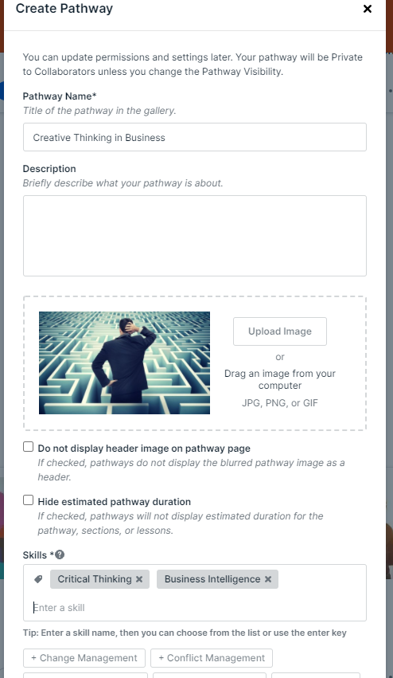

  - It will open the empty Pathway. Here you can add section titles to the Pathway. Click on Create Section.

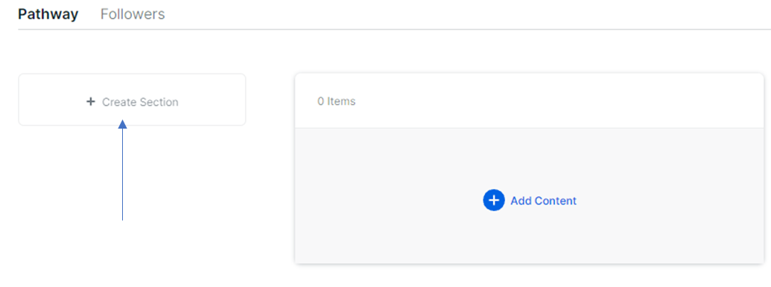

  - This will open up the section. You can add the title, a section description and add content from here.

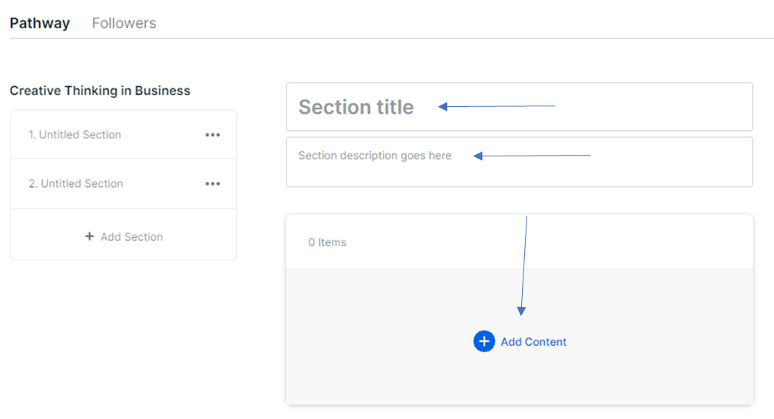

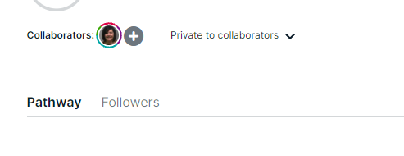
  - Once all the content is added to the Pathway click on the drop down Private to Collaborators to make this Pathway visible to employees.

  - An info box will open then click Visible to Organization then click Save Visibility.

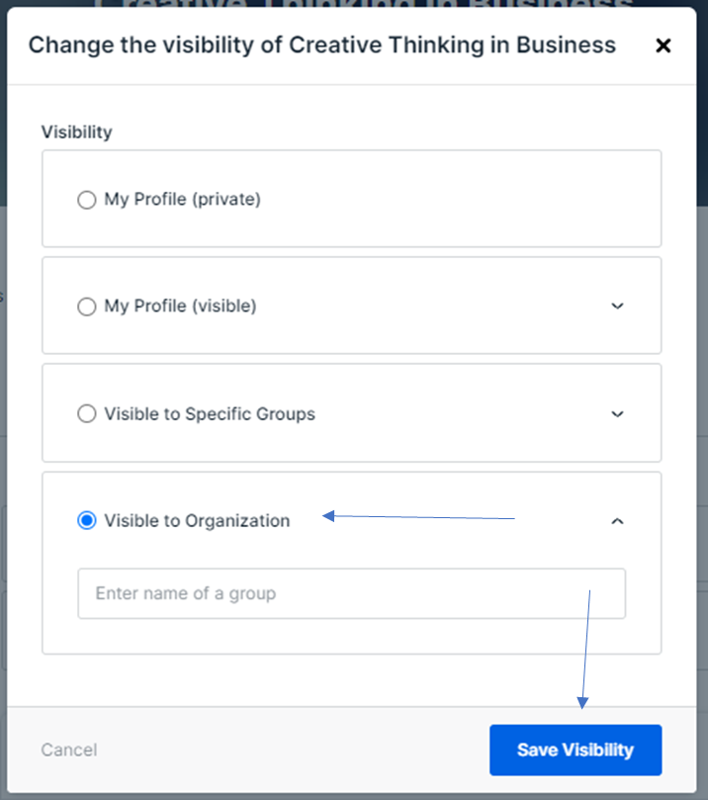

  - Now this Pathway is visible and ready to be assigned to employees

- Assigning a Pathway

  - To assign a Pathway, go to the Pathway you want to assign and click on the arrow.
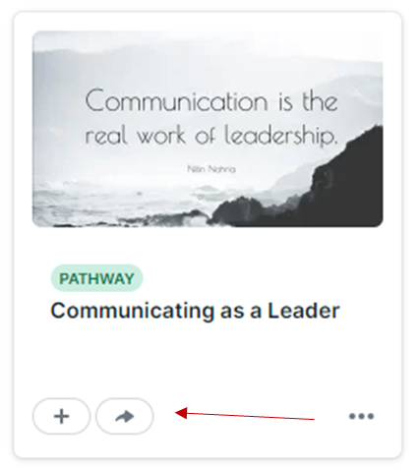
  - A box pops up that says Share the Pathway. A name has to be entered into the To: Box
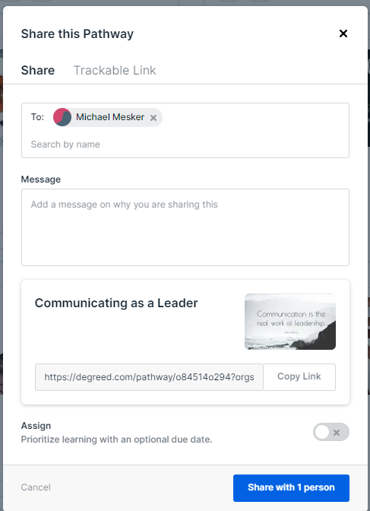

  - Then click on the button next to Assign at the bottom of the box and choose the date the Pathway should be completed.

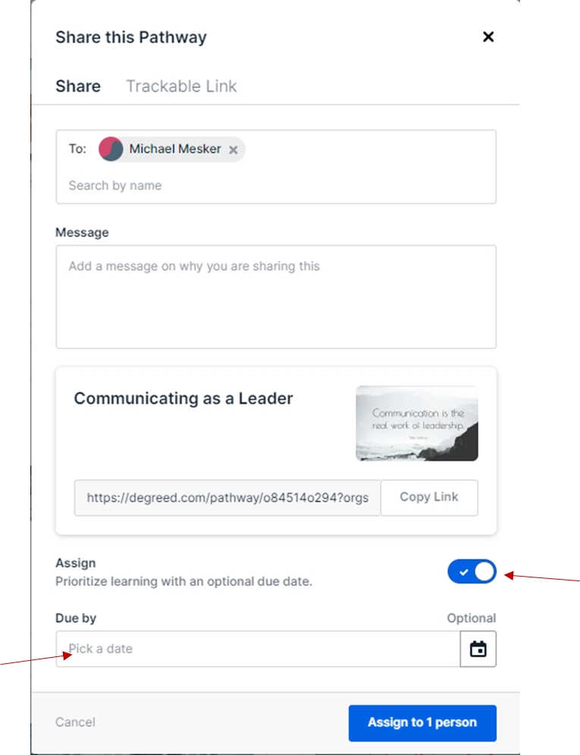

  - This will send a notification email to the employee that they have an assignment to work on.

Member User (Employee)
To build a successful career in the fast-changing modern-day, one must acquire a full suite of skills. Degreed Learning platform offers a place where employees can move between education and industry; gaining training, sharpening their knowledge, advancing their skills as they need them and ultimately make learning their competitive advantage. Degreed is a learning platform that is a one-stop shop for learning. Degreed offers learning content grouped into lessons called Pathways. These Pathways are packaged in a Plan that is focused on the Skill(s) you want to enhance.
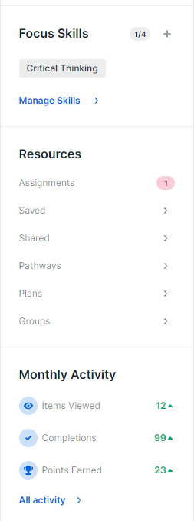
K&M uses this platform to house training materials and lessons used in individual development. Any employee can use this platform as a means of training. Talent Development is responsible for assigning the lessons (Pathways).

- Employee – Member User

  - User will log onto www.degreed.com. Click on Login button in toolbar.

  - After clicking Login you will be prompted to enter a username which is your K&M Tire email address and click Continue. Then you will be asked to enter a password. You will receive a password prior to this from Talent Development via email. Enter that password and click Continue.

  - This brings you to your home page. Any Assignments assigned to you by Talent Development will be noted under the Resources section on the left-hand side of the screen.

  - You will also be notified of Assignments via your K&M Tire email.

  - Click on Assignments under the Resource section of your homepage and it will take you to the Pathway that is assigned to you by Talent Development. (Or you can click on the link in the email you received with your assignment.) Click on the Pathway you are assigned to reveal the content.

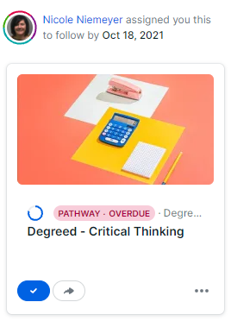

  - After you open the Pathway, start at the top and finish content in the order it is presented. To open content just click on the title of the content and it will open up.

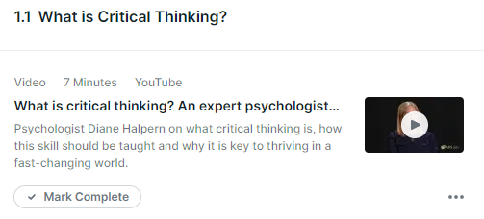

  - After you have completed the content, click on Mark Complete to show you have completed that content.

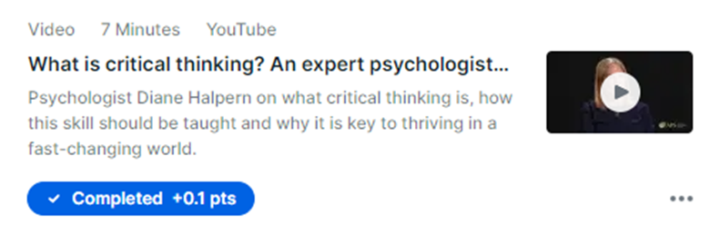

  - All Pathways will have a due date on them when assigned and must be completed by that date. The material taught in the Pathway will be discussed at a coaching session with Talent Development.

  - After completing content in a Pathway, the employee is able to give content a Thumbs Up or Thumbs Down depending of if the employee found value in what they learned. You can also share this content or write a comment about the content.


  - By Liking, sharing or writing a comment, the system will share additional content with you on that same or similar topic. You will find this additional content on your homepage.

Designing a Development Plan in Degreed
- Start by logging onto Degreed at www.degreed.com . Only Admins have access to make Development Plans.
- Next Click on the 4 boxes icon in the upper right corner of the home page then click on Manage K&M Tire.
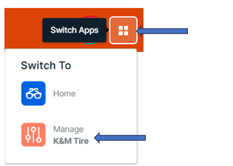
- Then Click on the Create a Plan or Directory button.
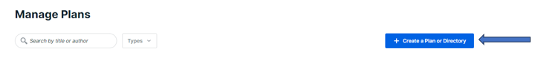
- This message box will open up then click on Plan.

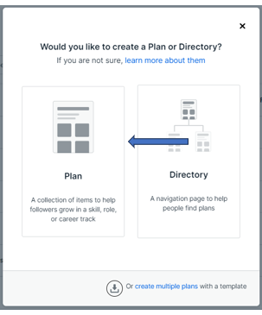

- Another message box pops up. Fill in the Title with the Employee’s name, Subtitle with Mid-Level Leadership Training (or the program title).
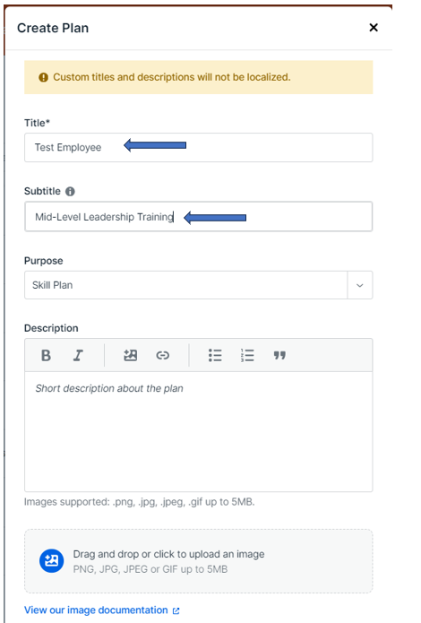
- Then Click on Visible to Organization and then click on Create Plan.

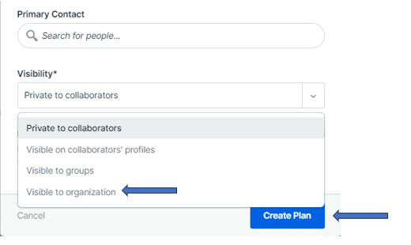

- Click on Add a Section and then click on Mixed Resources.

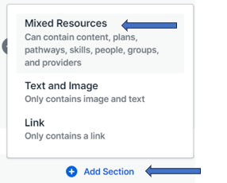
- Add a Title by typing Lessons, then add to the description the skill the employee will be trained in.
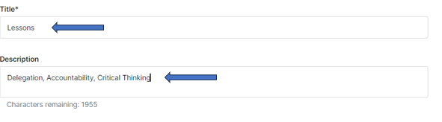
- Then click on Add Resources to add Lessons to this Plan.
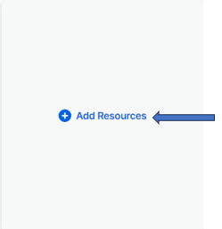

- Another message box will open up. Type in the skill to find the lesson (pathway) you are looking for. Then click on the Add Item button.
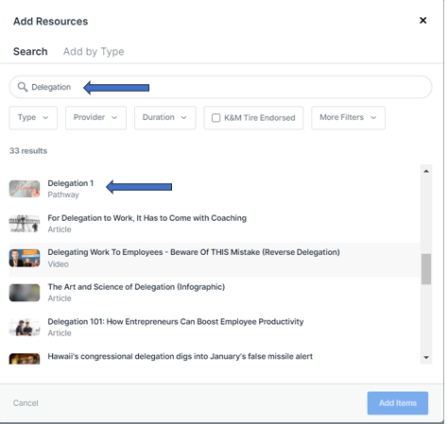
- It will then be added to the Development Plan and will look like the example below.


- Continue that process until you have all lessons (pathways) you want added to the Development Plan. Then click on the Done Editing button in the right-hand corner of the page to finish.
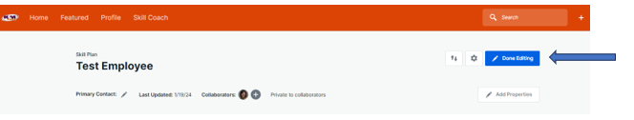

Predictive Index

Predictive Index Behavioral Assessment SOP
The Predictive Index is a system that measures what drives behaviors at work with individual employees or within teams. This system is meant to discover how to impact behaviors, ignite enthusiasm and align business strategy with talent strategy.
- An email is sent to candidate first. Sample below:
Hello NAME –
I am the Manager of Talent Development at K&M Tire. The Vice President of HR asked me to send you the Predictive Index Behavioral Assessment.
Here at K&M Tire, we believe that our people are our most valuable asset. We are committed to providing a dynamic environment where everyone can be their best. To help us do this we ask that you take the Predictive Index Behavioral Assessment. By taking the assessment we learn what drives and motivates you. We have found that by using the Predictive Index tools we are able to foster self-awareness, which helps us communicate effectively, strengthen team dynamics and improve manager-direct report relationships.
This assessment will be sent from Predictive Index, not my email, so please check your spam mail box if you don’t see it by this afternoon. I will be sending it shortly. Please take this assessment by Wednesday, December 22, 2021 at noon.
- Log into Predictive Index at www.predictiveindex.com
  - Username: Nicole.niemeyer@kmtire.com
  - Password: @Twinning1212
  - Opens up to Dashboard

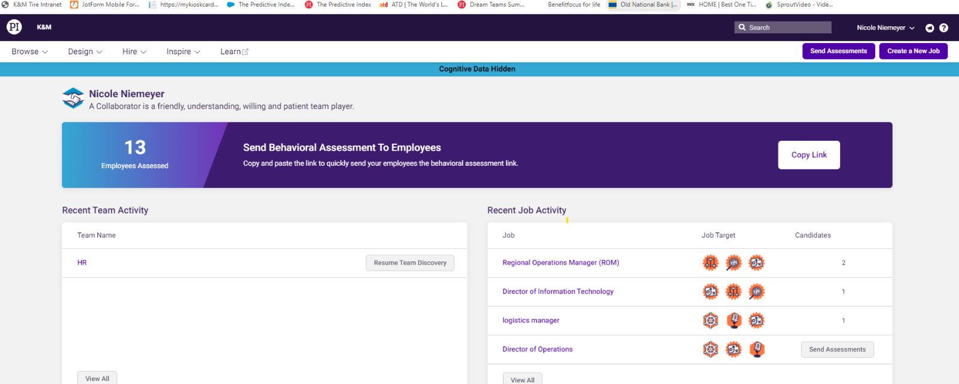
- Click on Send Assessment
- Type a name or email into the search bar.
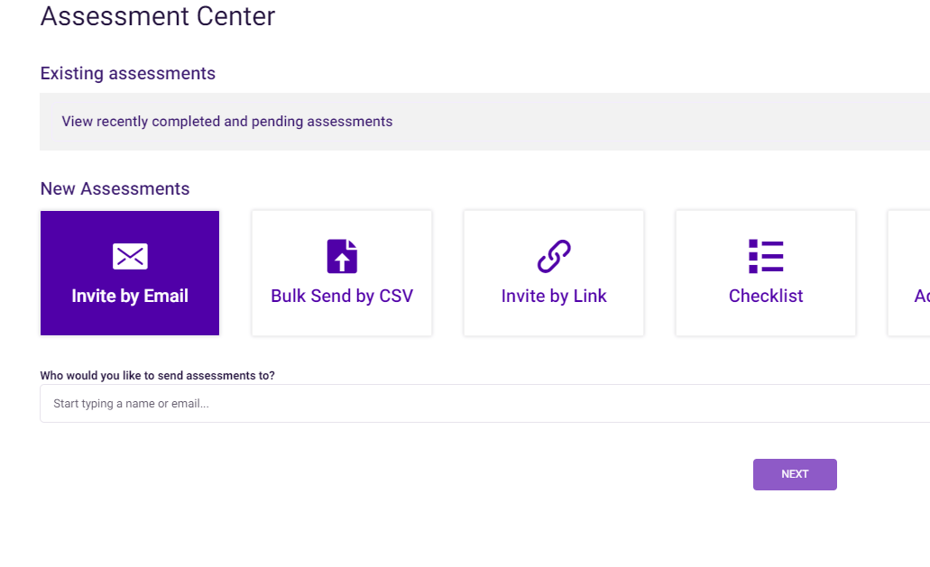
- Click on Create (insert name or email that is being looked up) and click NEXT
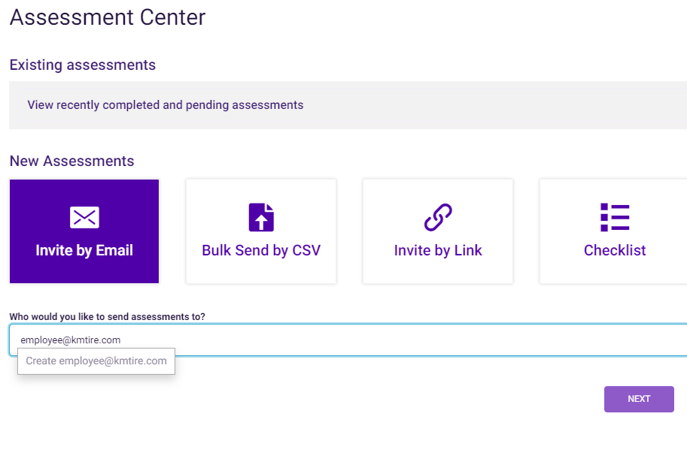
- For a new employee or a candidate for new position that is not in the system, Create New Person by entering Name, Email Address, choose What Type of Person is This. Then click on purple box that says Create New Person.
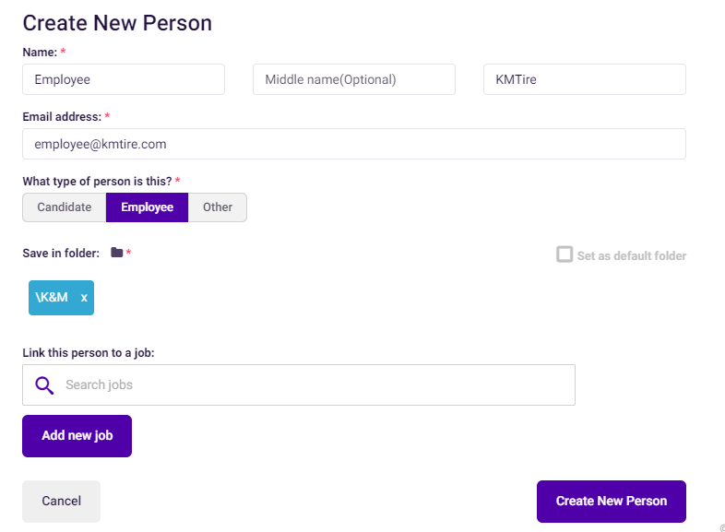

- On the next screen click NEXT.
- On the next screen make sure that Behavioral Assessment is highlighted in Blue (if it isn’t, just check the small box below Behavioral Assessment) the click NEXT
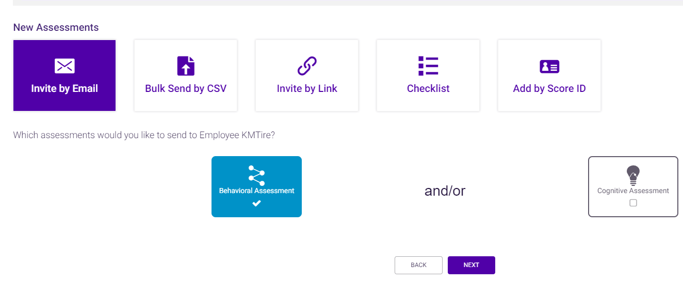

- On this screen you can just use the default message or you can type specific instructions telling candidate the next steps. (I usually just use default message.) Then click SEND NOW and Predictive Index will send candidate a link to the Behavioral Assessment.
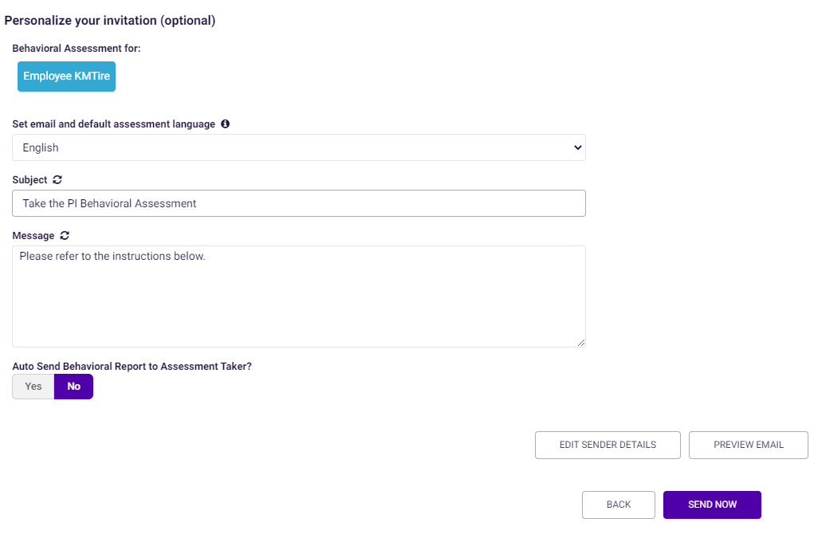

Predictive Index Behavioral Assessment Debrief
The Predictive Index is a system that measures what drives behaviors at work with individual employees or within teams. This system is meant to discover how to impact behaviors, ignite enthusiasm and align business strategy with talent strategy.
After an employee does a Behavioral Assessment Talent Development conducts a debrief of the results.
- After an employee finishes a Behavioral Assessment, Talent Development will get an email to notify that an assessment has been completed.
- Talent Development reviews results of assessment.
- Using definitions and instructions kept in a binder, Talent Development evaluates results by filling out a Predictive Index Readback form.
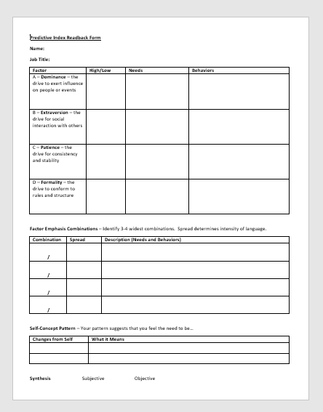

- After evaluation is completed Talent Development schedules a time to meet with employee to debrief employee on results.
- At meeting Talent Development explains that there is no pass or fail, this assessment is used as a retention tool and tells us the employee’s behavior and communication patterns in regards to a work environment.
- Then the debrief begins in which Talent Development goes over the behavioral patterns within the report.
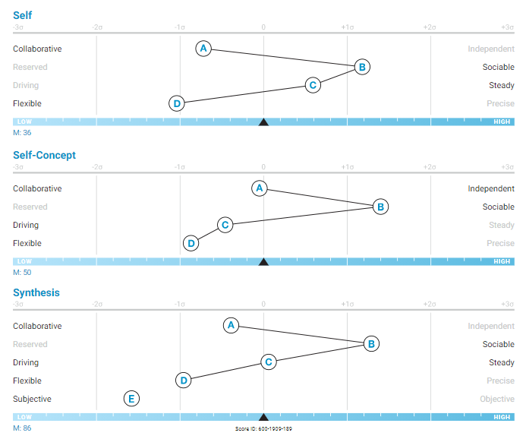
- All factors in the SELF graph – A-D – and what they mean in regards to the employee’s report is explained to employee.
- Then Talent Development will explain the distance between the factors that are the furthest apart.
- The Talent Development will explain the difference between the factors in the SELF graph and the SELF-CONCEPT graph and what that says about the employee’s behavior.
- Then to finished the debrief Talent Development will explain the E factor in the SYNTHESIS graph and what it says about the employee’s work behavior.

Training Programs

IDP Process
The Individual Development Plan was developed for individuals to work on one specific skill to engage employee and enhance their leadership skills. The IDP is a program where an employee is assigned learning materials such as videos, articles, books, experiential learning such as job shadowing, mentoring, etc. to help them understand and enhance their knowledge of a specific skill. The learning materials will be assigned through the Degreed Learning Management System (LMS) by Talent Development. After each lesson or “Pathway” the employee meets with Talent Development to discuss what the employee learned from the Pathway. They may discuss ways they can incorporate that skill into the employee’s everyday life, concepts that were mentioned in the Pathway, etc. This will go on until the entire IDP and Pathways have been completed.
- To go through the Individual Development Plan, an employee has to be nominated by their manager and/or ELT member. To be nominated the manager will complete the Nomination form and return to Talent Development. TD will forward form to President where it will be brought to the Executive Leadership Team for approval.
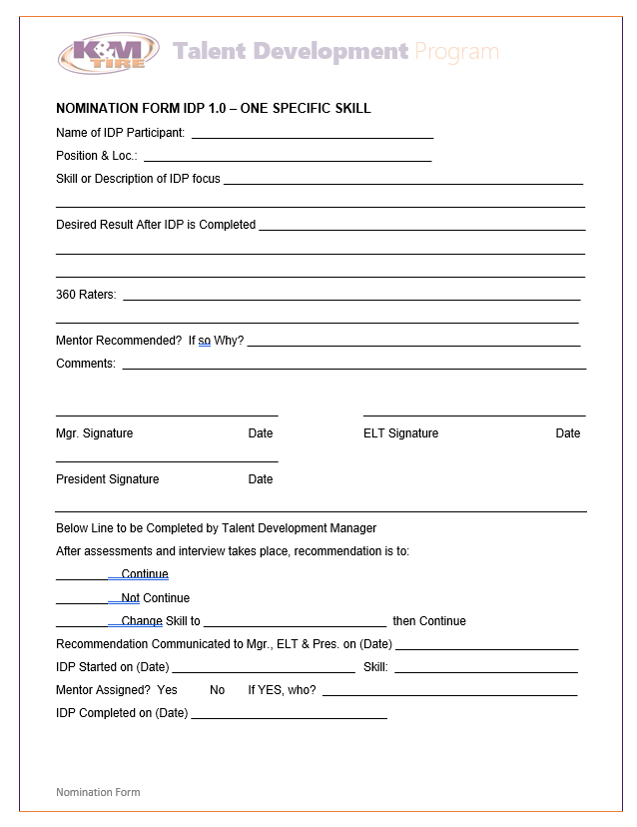

- Once the nomination is approved the manager will have a meeting with the employee explaining that they have been given the opportunity to work with TD on an IDP and explain what skill the employee will be developing. The manager will also discuss why the employee has been selected for an IDP.
- The manager will then have a discussion with TD to review the expectations. TD will review the brochures with the manager and review the IDP process. The manager then will give the employee the brochure so they understand the process.
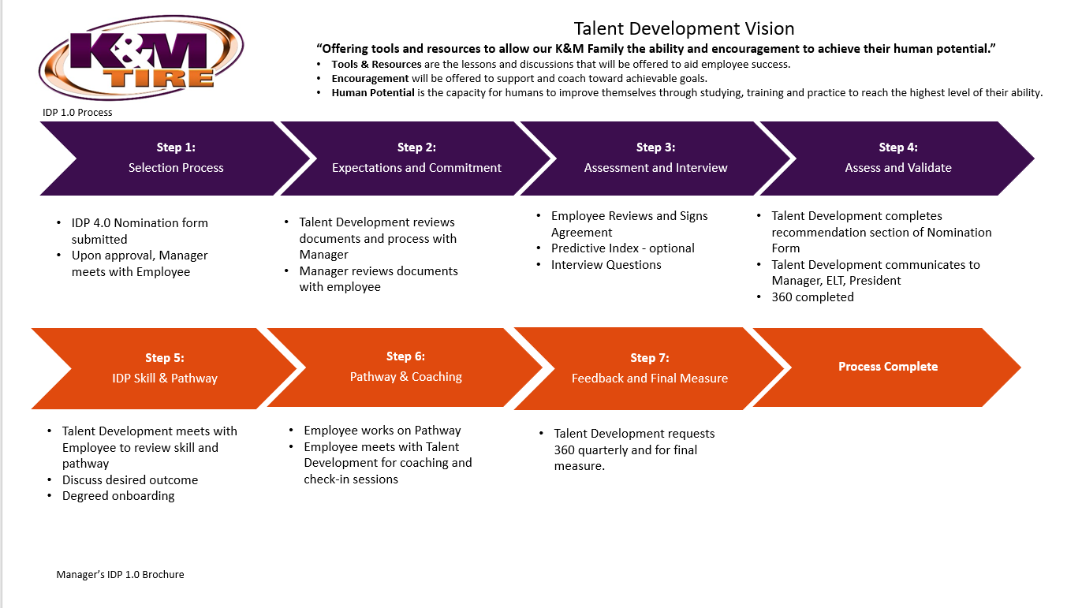

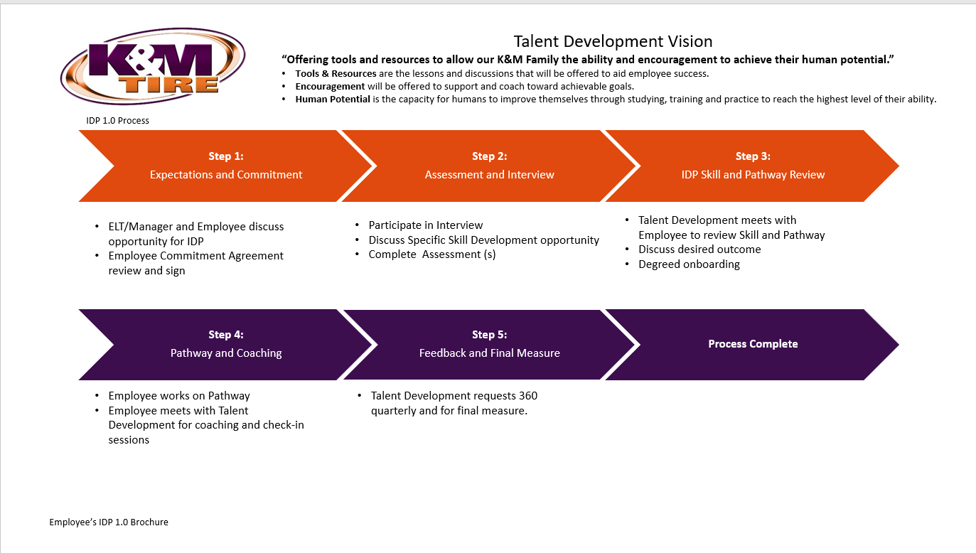
- During this time the employee will also receive the agreement that they will complete and give to their manager who will then forward to TD.
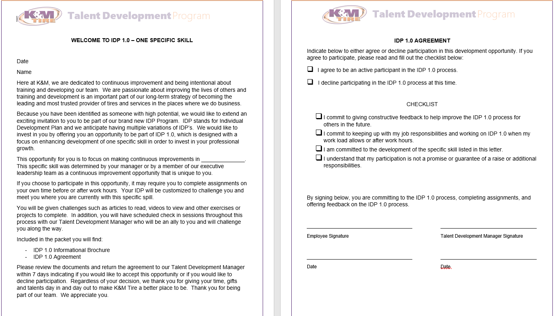

- TD will then meet with employee and conduct the interview. The interview is conducted with the nominated employee for the IDP. This process includes Talent Development and the nominated employee and is part of the Assessment step. Talent Development will ask predetermined questions and document the nominated employee’s answers. There are several things Talent Development is looking for by going through the Interview process.
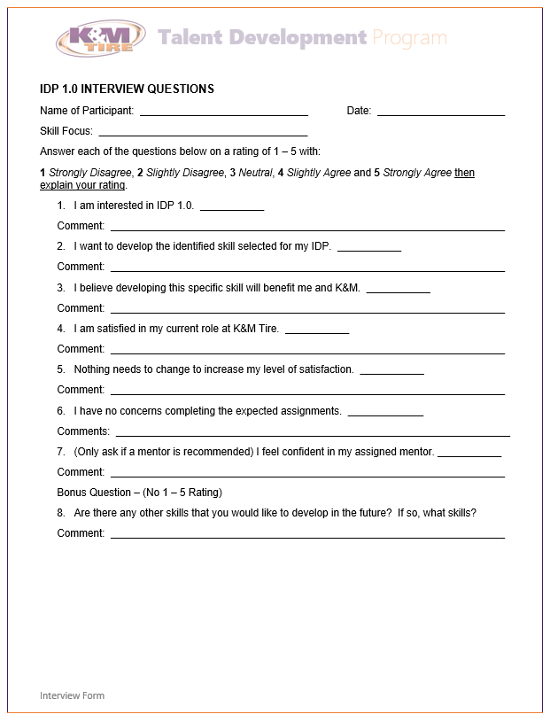

Questions:
- I am interested in the IDP.
- I want to develop the identified skill selected for my IDP.
- I believe developing this specific skill will benefit me and K&M.

- This selection of questions will help determine if the nominated employee is truly interested in participating in the IDP process and if they have an interest in developing the particular skill that has been chosen to be developed. At this point any concerns about the process or the particular skill can be tackled.

Questions:
- I am satisfied with my current role at K&M Tire.
- Nothing needs to change to increase my level of satisfaction.

- This selection of questions will notify if there is job dissatisfaction, mismatch or if the nominated employee is interested in growth within their department or the company as a whole.
- TD completes/signs the Agreement and communicates with President and employee’s manager that the employee is interested in the development opportunity or not. If the employee is interested in the development opportunity, a 360 assessment will be sent out to the employee, employee’s manager, and other designated colleagues within the organization.
- Manager and TD assemble a list of 360 Assessment Raters for the employee’s 360 Assessment. Notification is emailed to the Raters explaining to them why they have been selected and the reason for the 360 Assessment. The Rater Assessment for is sent to all Raters and the Employee Assessment for is sent to the employee to be completed. After collected, data is compiled and saved in spreadsheet.
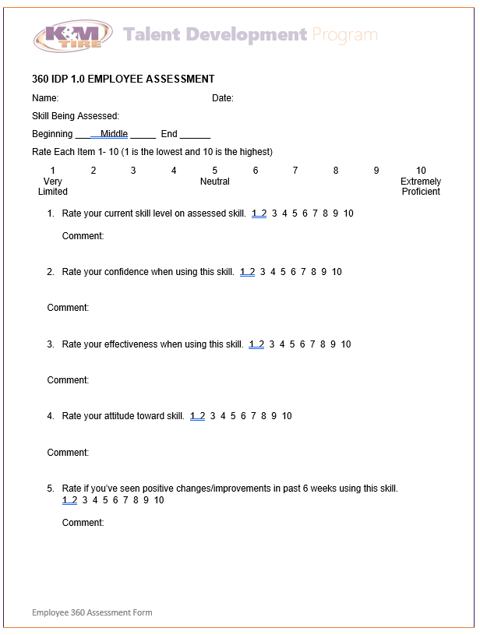
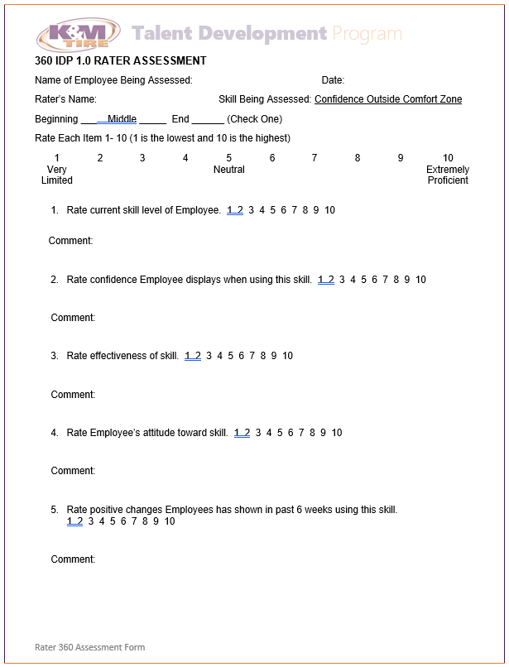

- TD completes the IDP form and reviews with Manager and then reviews with employee.

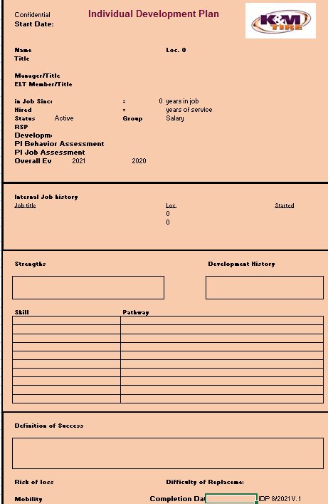

- TD meets with employee to review the IDP and development strategy, outcome, and then conducts Degreed onboarding. (See Degreed SOP Member User – Employee)
- TD then assigns the first Pathway in the Degreed Learning Management System and sets a completion date. (See Degreed Instructions on Setup SOP – For Talent Development) TD then sets up a time to meet with the employee to review what they learned in the Pathway and how they can incorporate it into their position. This process continues until all Pathways have been assigned and completed. One Pathway is assigned per month.
- TD will send out the 360 Assessment to the employee and the Raters quarterly to rate the progress the employee is making in their development. TD reviews the result metrics of the 360 Assessments with the employee.

Leadership Fundamental Training
Leadership Fundamental Training is for those employees promoted to a Level III employee. It states in the Level III employee job descriptions that it is mandatory they go through leadership training. This training was developed for those individuals. Due to all departments not having level (I, II, III) positions, the training has been opened up to individuals that would benefit from going through this entry level leadership training. Employees that are not Level III employees are nominated by their Manager or ELT member, and brought to the Executive Leadership Team for approval.
Leadership Fundamental Training was designed to help employees start to think like a leader by training them on entry level leadership competencies and growing the employee’s skill set.
- The Leadership Fundamental Training meets once a month. This training is based on John Maxwell’s book The 21 Irrefutable Laws of Leadership and each month one law is discussed. They go in the order John Maxwell has them in the book. This training is more discussion based and uses case studies and real-world examples. There is a K&M team member who is a guest speaker at each training session that speaks for 45-60 minutes on the topic of that month. This speaker offers real world advice, examples, situations or activities for the participants to learn from.
- The very first month of training starts off with the rules of the training sessions and an explanation of how the sessions are designed and what the participants can expect from the training sessions. The second training session and going forward start off with a review of the participants action plan from the previous month. Talent Development asks participants to volunteer to tell the group how their action plan worked, didn’t work, what changes they had to make, who helped them, etc. All participants’ Managers are invited to this portion of the training session so they can hear about what their employees are learning from the training. After this portion all managers are thanked and told that the review portion of the training is over and they are excused.
- Next the participants watch a video of John Maxwell explaining the Law they are learning about that month. Below is a link to the first law in the book, the Law of the Lid.
https://www.youtube.com/watch?v=UZC7HePt5P8

- The video for the law the participants are working on that month is shown and then discussed.
- Next, we review some concepts from the video or concepts related to the topic. We also use real world examples or video clips to help understand the concepts. This is structured as a large group discussion.

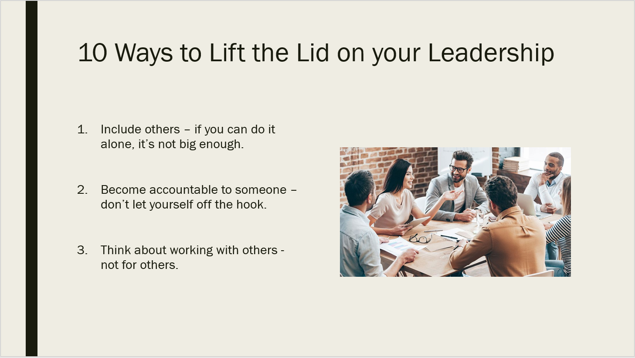

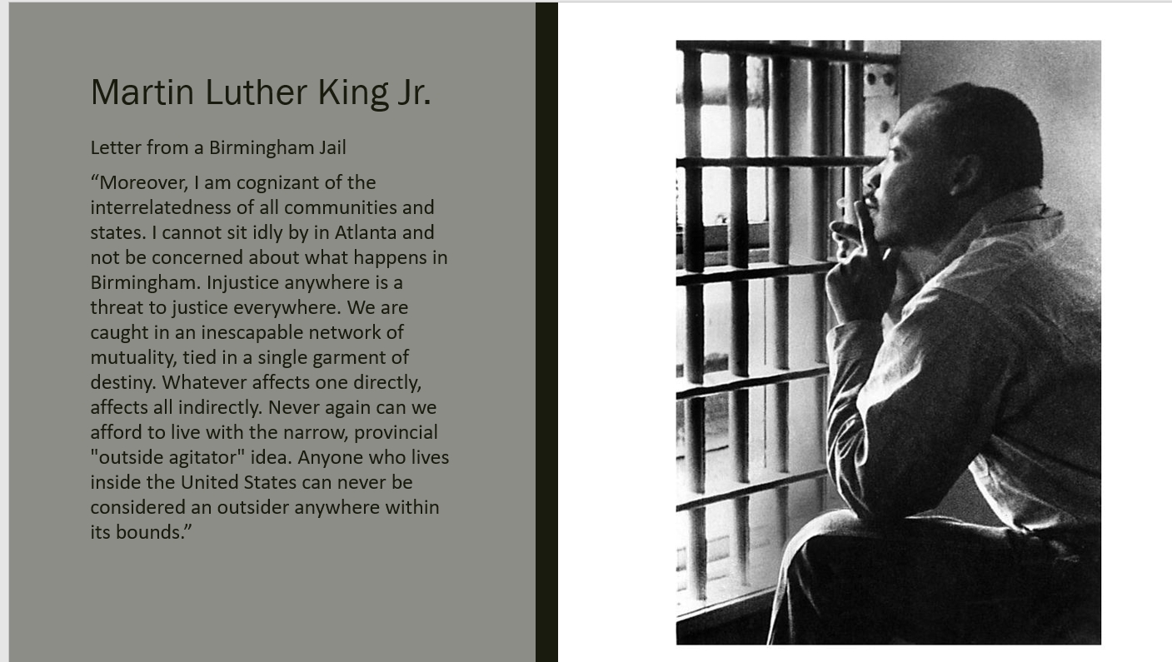

- In some chapters TD uses video case studies to help the participants understand the concepts. This gives the participants a better visual. After the video is shown TD and participants discuss the video and how it relates to the chapter and law being taught.

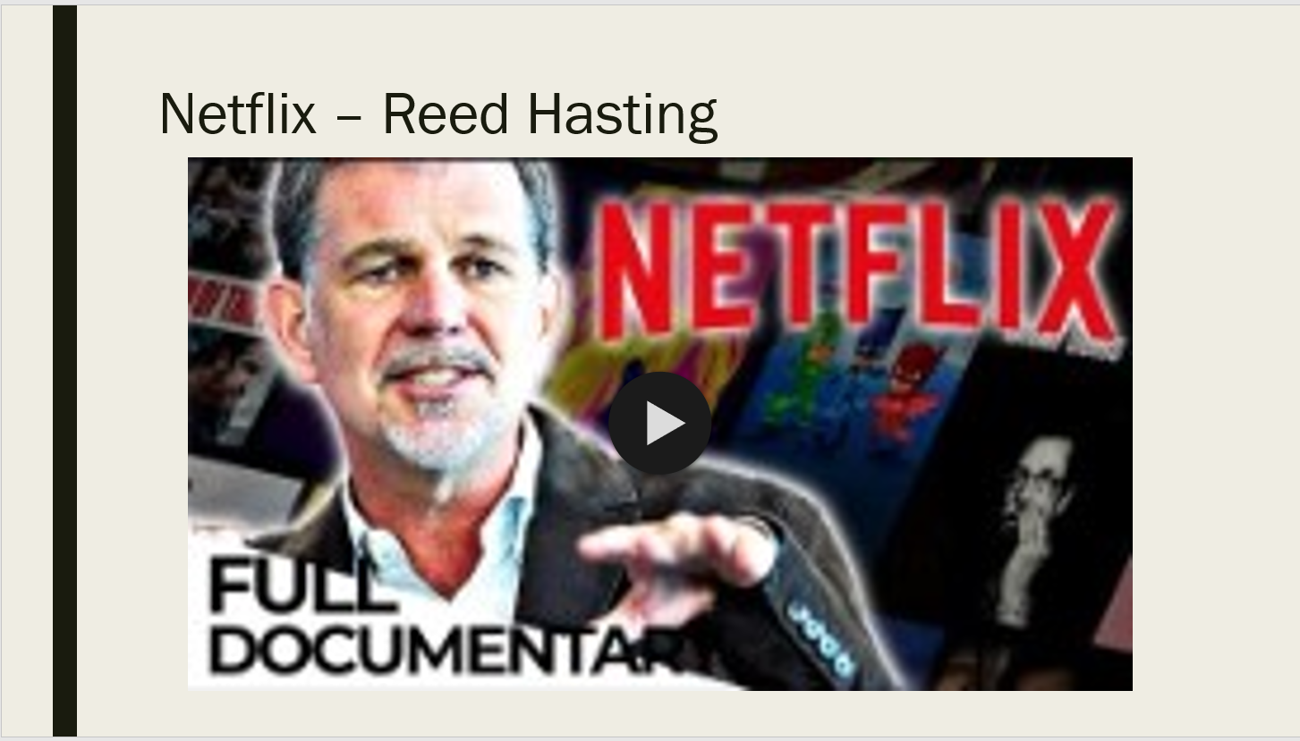
- Towards the end of the session TD shows a video that Training and Development has put together explaining the law further. These are great reviews of the concepts the participants learned throughout the day.

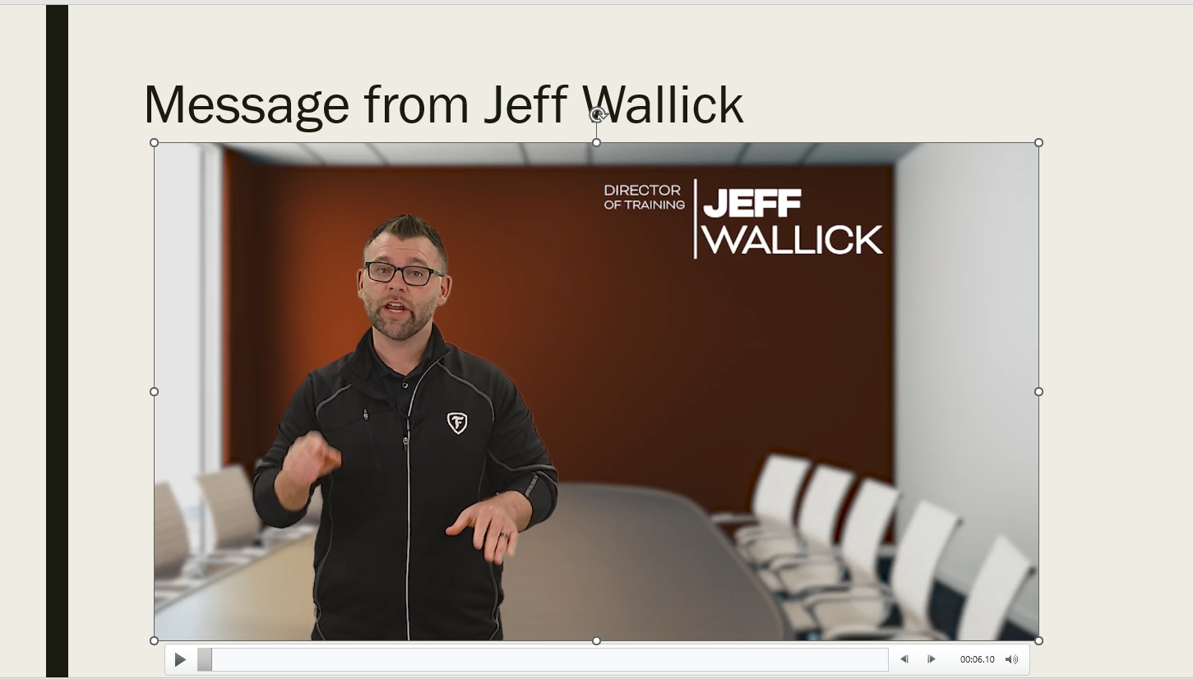
- Then to close the session the participants get into small groups and put together an action plan. This action plan is then used to help the participants put what they learned into action within their job here at K&M Tire. To help the participants put their action plan together, TD offers questions they can answer and/or think about assisting them in making goals and coming up with tasks to help achieve those goals. Participants get into groups of 2-3 and work together to put their action plans together.

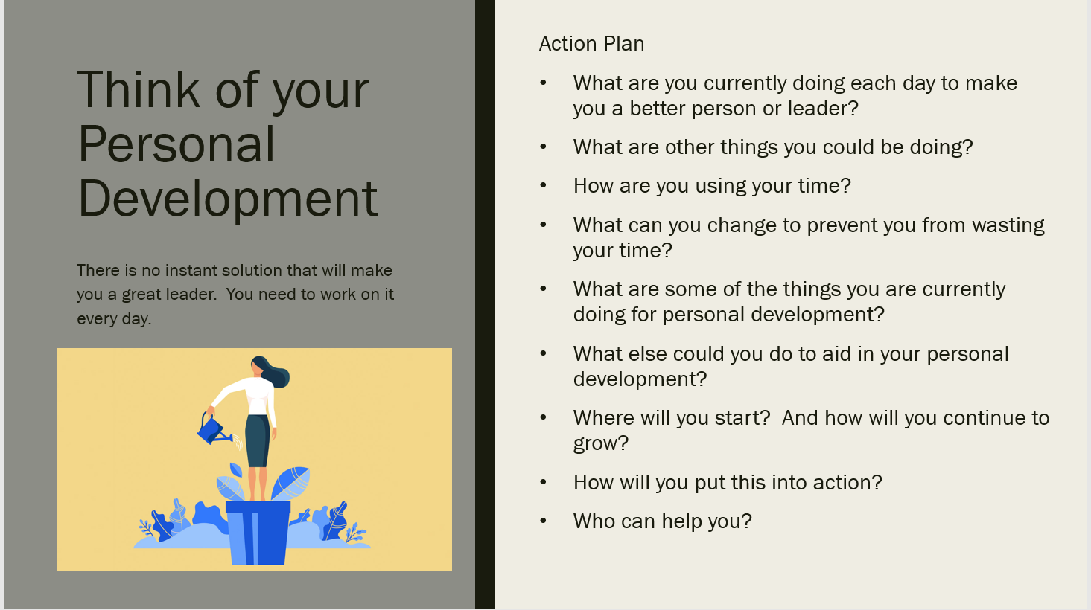

  - TD developed an Action Plan Form to assist participants in writing goals for their action plan. This is just a guide and participants can use it if they need it, or they are open to coming up with their own way to put an action plan together.
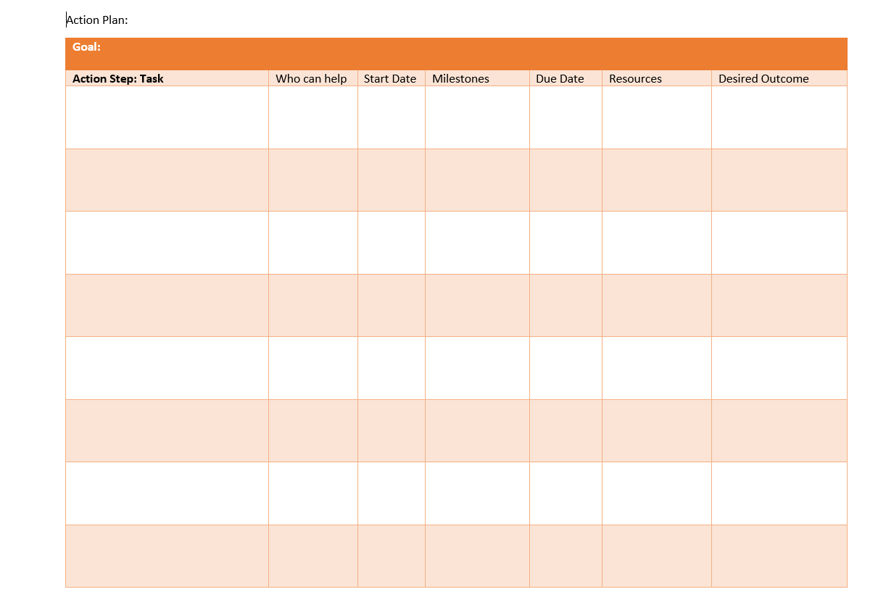
- The participants get 20-30 minutes to work on their action plans. Then TD asks for volunteers to explain what they came up with for their action plan. At this time other participants can give suggestions, ask questions or give advice to the volunteers to give them a different perspective and think of things that they hadn’t thought of.

Surveys
- Participants are sent a Pre-Training Survey 5 days before the training session. This is to be done to measure how much the participants know about the topic before they go through the training. The survey is sent to participants through Paylocity and consist of 5 questions. Then 30 days after the training session they are sent a Post Training Survey that consists of the same 5 questions to gauge how much the participants learned from the training session and putting their plan into action. The questions are different for each law and pertain to the topic the law is based on. These surveys are found under Surveys in Paylocity

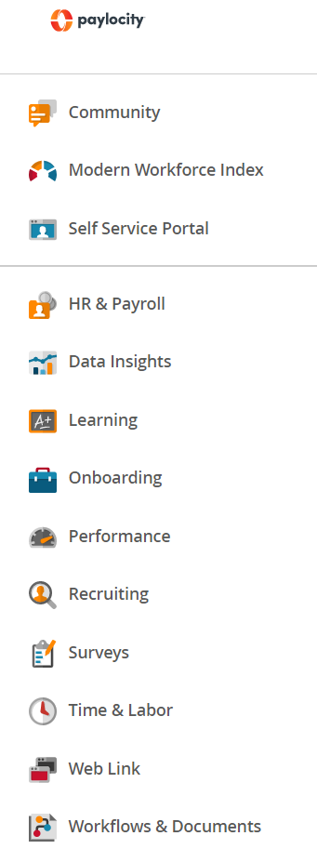

- Then click on Survey Library at the top to show a list of surveys. Then click on the survey you would like to view.

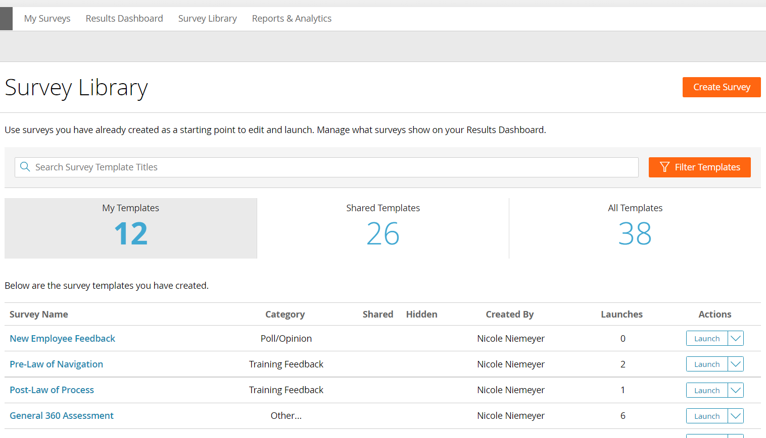

- To find the results of the survey in Paylocity, click on Results Dashboard and click on the survey name to see those results.

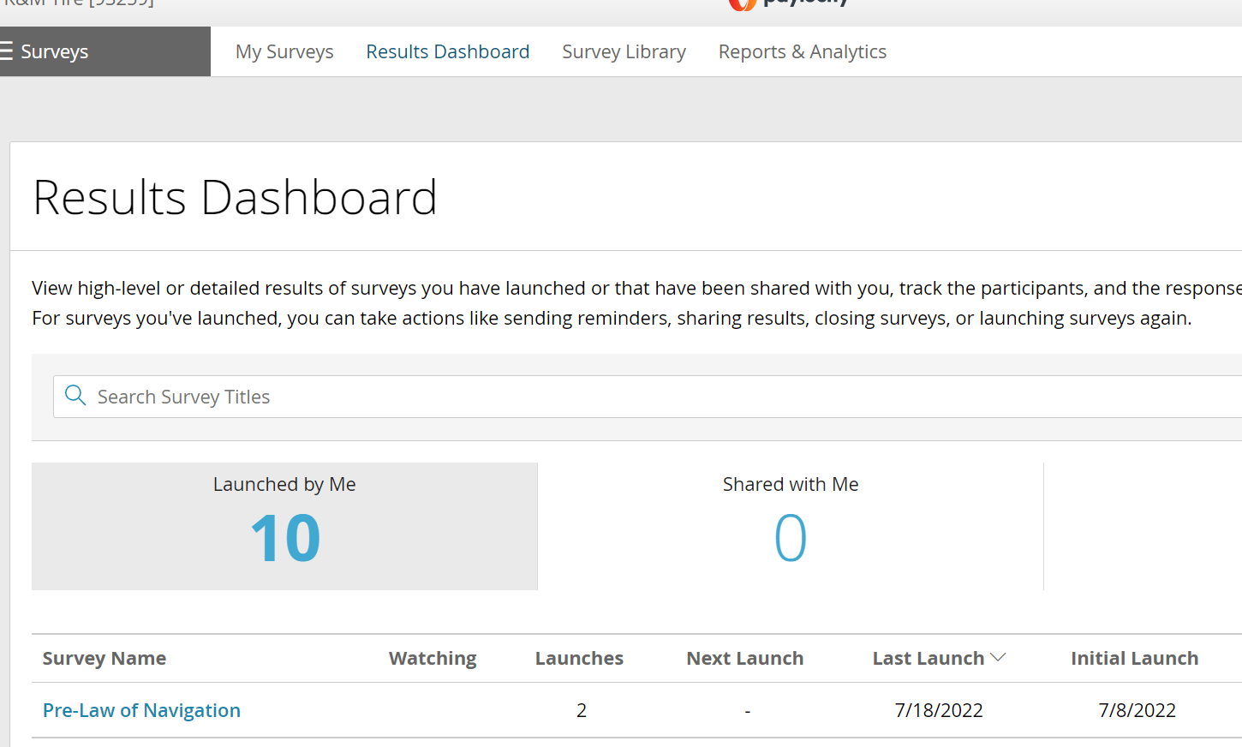

- From here all results can be uploaded into an excel sheet and used for the KPI.

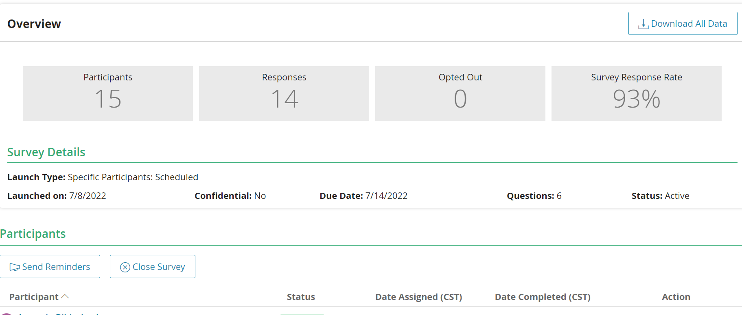

Mid-Level Leadership Development Program
The Mid-Level Leadership Development Program was developed for individuals that are identified as potential mid-level leaders within the organization. The Mid-Level Leadership Development Program is designed specifically with each participant in mind and tailored for the participant’s specific developmental needs. The program consists of individual learning through lessons from a learning management system (LMS) followed up by a one-on-one coaching session with Talent Development. This program contains 8-12 participants at a time.
      - Participants
- To be nominated an Executive Leadership Team member will complete the nomination form. This form consists of a list of topics the ELT member can choose for the participant’s development.
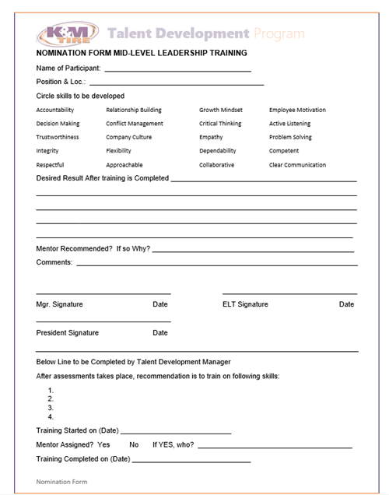

- The ELT members bring their nominations to the ELT meeting discuss or finalize participants, and then is approved by the President.
- Once approved the Development Department will receive the nomination forms to design an electronic Development Plan on the LMS, Degreed.
      - Development Plan
- Once the participants have been selected and informed Talent Development will develop a Development Plan custom to each individual participant.
- The Development Plan is done by logging onto Degreed and going to the Manage K&M Page by clicking on the 4 squares at the top right-hand corner of the home page then click on Manage K&M Tire.
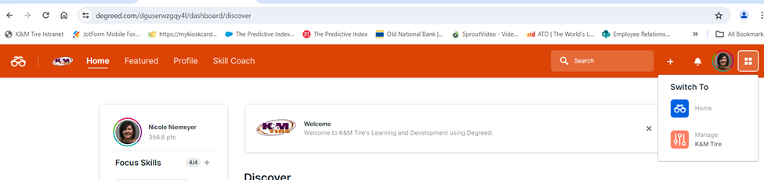

- Click on Plan at the top of the page and then click on the Create a Plan or Directory button on the right side of the page.

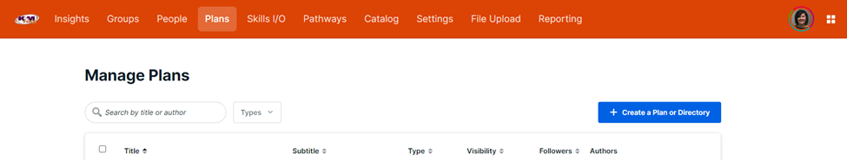

- A message box will pop up. Click on Plan to start the Development Plan.

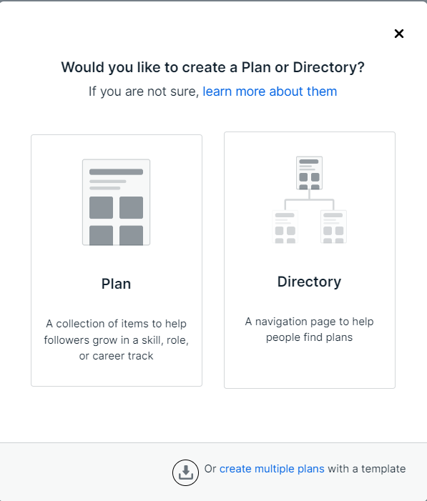

- Another message box will pop up. In the Title box put the participant’s name. In the Subtitle box enter Mid-Level Leadership. The Visibility drop box choose Visible to Organization. Then click Create Plan.
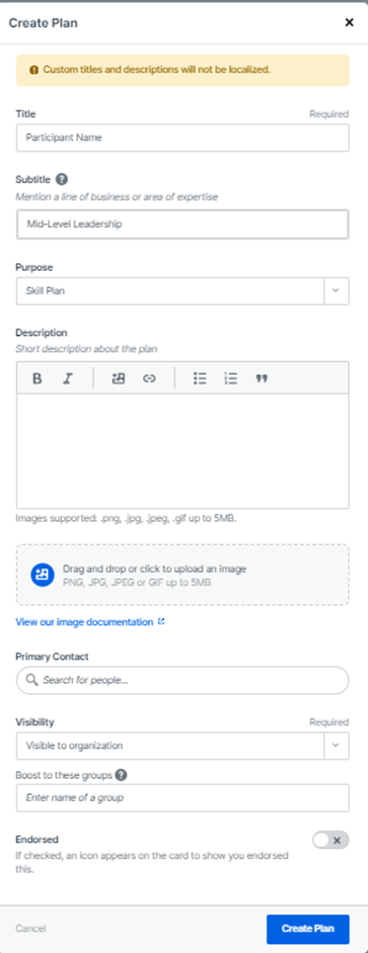

- Once you have made the development plan you will need to add the lessons which are called Pathways on Degreed. Most Pathways for the Mid-Level Leadership are already completed and saved in the Degreed system. After opening the Development Plan click on the Add A Section button in the middle of the page.
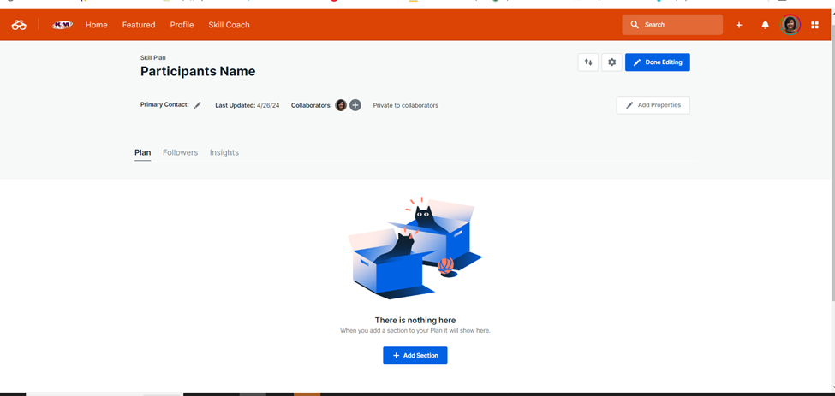

- A text box will pop up. Click on Mixed Resources. A new section opens up and you can now add information. The title would be Mid-Level Leadership. Add the topics to be developed from the Nomination form to the Description. Then click on Add Resources to add the Pathways.
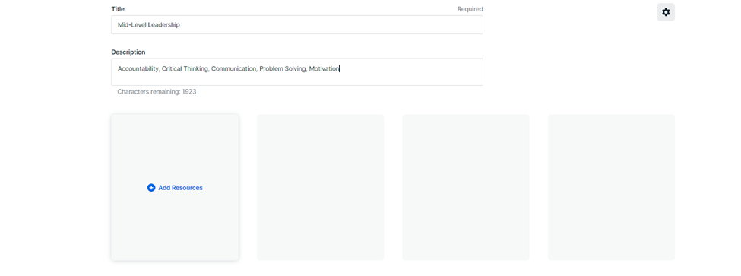
- Once you click on Add Resources a message box will appear. Type in the topic of the Pathway into the search bar then click on the Type drop down menu and click on Pathway. This will show all the Pathways containing that word or words. When you find the one you want to add click on it then click Add 1 Item. Continue this process until you have added all the Pathways to the Plan.

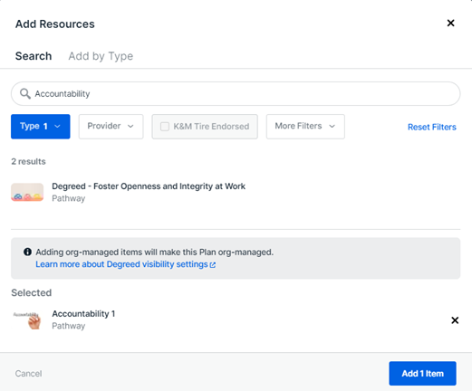

- Next you will put the Pathways in the order in which the participant will be assigned to them. To do this click on the Reorder Items button then drag the Pathway into the order you want to assign the Pathways.
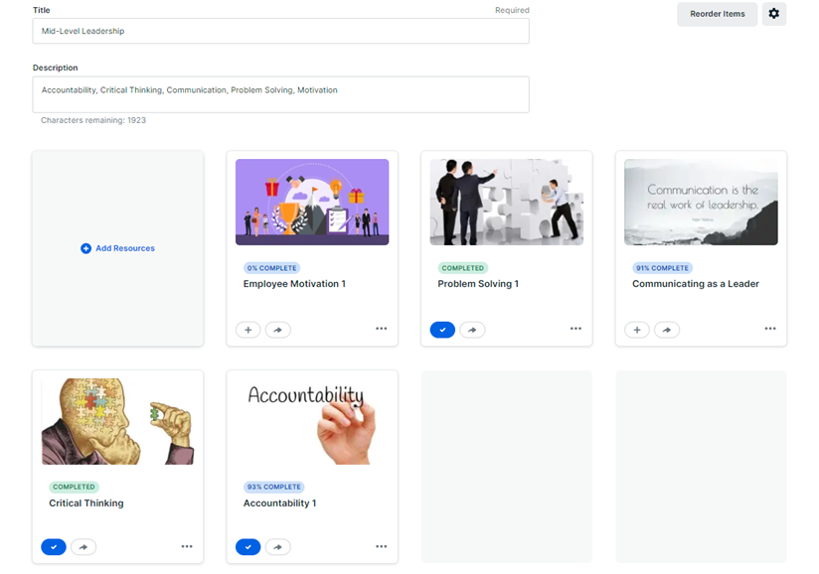

      - Initial Meeting with Participant
- Set up a time to meet with each participant individually to train the participant on how to use Degreed.
- Show the participant where to find his/her newly assigned Pathway.
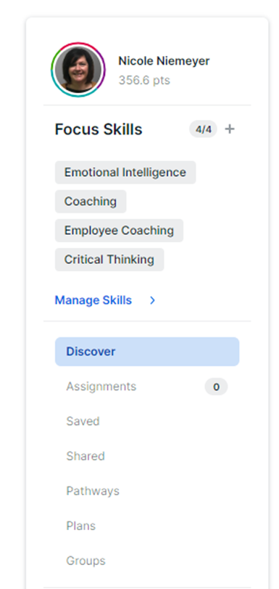
- Explain the homepage and that the Pathways showcased on this page will generate dependent on what the employee is studying or searching.
- Review the employee's Development Plan with them by letting them know what topics they will be studying.
- Ask if the participant has any questions and answer them.
- Assign the participant their first lesson and set up a date 30 days or so from the date their lesson was assigned.
      - Coaching session
- Coaching sessions are held in person in Training and Development’s office if the participant is in office. If the participant is a Warehouse employee the meeting is conducted via Teams meeting. Coaching sessions are scheduled for 30 days after each Pathway is assigned for the duration of the Development Plan.
- Coaching sessions consist of talking about the topic the participant was assigned by asking questions related to the material in the Pathway. Questions can be found in F: Drive.
  - F:\Training & Development\Shared\Mid-Level Leadership\Career Coaching
- Questions are asked to ensure that participants comprehended what they learned, how the participant can use what they learned on the job and how the participant can pass what they learned on to their team.
- Coaching sessions last approximately 30-45 minutes.
- This process continues until all Pathways have been completed.
- Training and Development then adds a summary of each participant’s lesson in Monthly Communication.

      - Halfway Through Development Plan
- Training and Development will meet with the participant’s manager halfway through the Development Plan to discuss progress, determine if the manager would like to add anything to the participant’s Development Plan and so the T&D Manager can collect feedback.
- If the Development Plan doesn’t change the participant continues until the Development Plan is completed.
- If the participant’s manager wants to add additional topics, T&D Manager will do so and notify the participant at the next coaching session. Then the Development Plan continues until completed.

      - Ending of Development Plan
- The designated coach will schedule a meeting with the VP and/or Manager of the participant when there are 2 sessions remaining in the participant’s development plan to discuss whether the employee is advancing and will complete the program or should additional topics be added to the development plan.
- At the last coaching session T&D Manager will ask the participant to follow up with an email explaining what they took away from going through the Mid-Level Leadership program, what they liked about the program and if they have any suggestions for improvements to the program. This information will be added to the T&D Manager’s Monthly Communication.

Frequently Asked Questions
K&M instructions: Provide information on how the Warehouse Manager can get emergency assistance and system support (e.g., help desk support, inventory support, etc.). Include the names of the responsible personnel and organization(s), telephone numbers, and email addresses of the staff who serve as points of contact for system support.

Table 1 - Support Points of Contact
Contact / | Department | Phone | Email | Role
K&M Corporate Line | Corporate | 419-695-1061 | n/a
Jeff Wallick | Training & Development | 419-236-0288 | Jeff.Wallick@kmtire.com | Director of Training
Nicole Niemeyer | Human Resources | 419-695-1061 x3072 | Nicole.Niemeyer@kmtire.com | Manager of Talent Development

Appendix A: Miscellaneous

A.1) Sprout Video Platform
To effectively utilize our Sprout video-hosting platform, please view this short video
SOP. (Full hyperlink here: https://kmtire.vids.io/videos/069ddeb31a19e6c18f/sproutvideo-com)

A.2) Intranet Online Training Portal:
In order to successfully use our intranet training portal, please view this short video SOP.
(Full hyperlink here: https://kmtire.vids.io/videos/ac9ddeb31a19e5c025/intranet-training-portal)

A.3) Jotform Survey Platform
To successfully utilize our Jotform online survey platform, view this short video SOP.
(Full hyperlink here: https://kmtire.vids.io/videos/ea9ddeb31a19e5c663/intranet-training-resources-library)

A.4) Intranet Training Resources
To understand how to use our online training resources library intranet program, please view this short video SOP.
(Full hyperlink here: https://kmtire.vids.io/videos/ea9ddeb31a19e5c663/intranet-training-resources-library)

Appendix H: Revision History Tracking
The following table records information regarding changes made to the Operations Binder.

Table 6 - Revision History Tracking
Version Number | Date | Author/Owner | Description of Change
 | 2/5/2021 | Angie Prichard | Updated/Added 5.3, 5.4, 5.7, 5.13, 5.15, 5.18, 5.21, 5.23 & 5.24  Section 6 Table 1  Appendix A: Miscellaneous
 | 2/19/2021 | Angie Prichard | Updated/Added 5.12 & 5.27
 | 2/26/2021 | Joni Zerkel | Link added: distribution list
 | 5/12/2021 | Angie Prichard | Updated 5.3, 5.19 & 5.25
 | 11/14/2022 | Shaina Johnson | Section 6 - 10
 | 8/25/2023 | Kayla Perrine | Added CG Shorts
 | 1/26/24 | Jody Keller | Designing a development Plan
 | 12/5/2024 | Angie Prichard | Updated 7.4 Mid-Level Leadership

